**SMART CITY INFRASTRUCTURE**

**PROJECT CODE**

**Concepts Of Computer Networks Applied:**

* Ip Addressing Static
* HTTP/HTTPS
* DHCP Services From Server
* DHCP Services From Router
* DNS Service
* SMTP Services
* FTP Services
* IOT Services
* SSH Protocol on Router/Switches
* Subnetting of Ip Addresses
* Default Routing
* OSPF Dynamic Routing
* VLAN
* Inter VLAN Routing
* Wireless Connections
* Cell Towers
* MCU-Board

**Topology NOTE:**

* Smart Homes Runs independently
* Management Office is connected to Energy, Parking, and Internet Service Provider.
* City Headquarters and Other Department are in connection but wo different branches. They both are connected directly and also through Internet Service Provider
* City Headquarters have 2 floors with multiple departments.
* Other Department have 2 floors with multiple departments.
* Server Site is part of City Headquarters.
* All the smartphones and tablets can be connected to any cell tower present in Internet Service Provider.

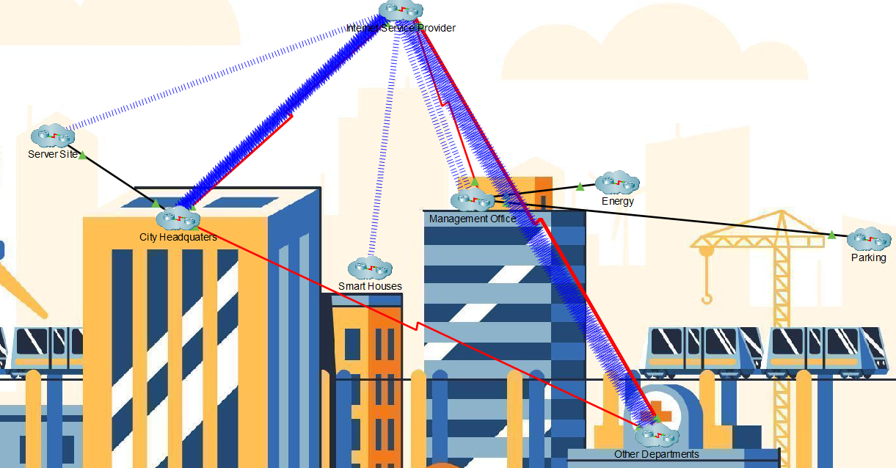

**Smart Homes:**

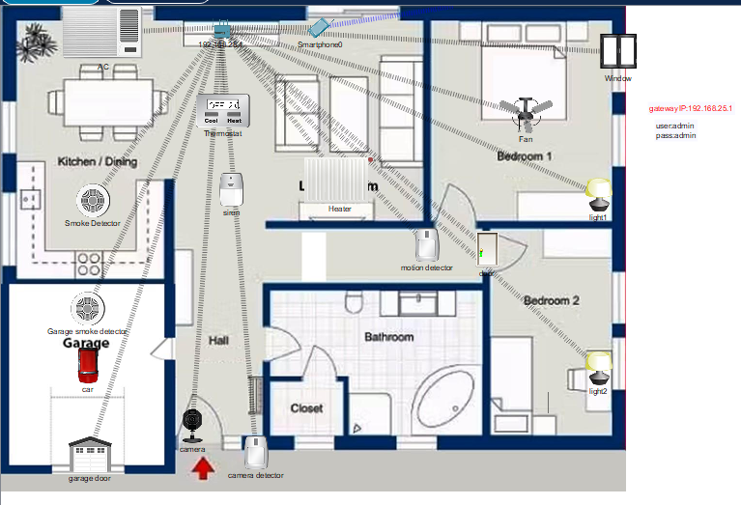

Smart homes are entirely independent and have to connection to the outside world. It contains a wireless device known as **HomeGateway** with **IP Address:192.168.25.1** and its **SSID: HomeGateway** for wireless connection of IOT devices. There are many IOT devices dependent on each other with multiple condition set by the owner of the house whose **Username: admin** and **Password: admin.** The conditions on which the IOT devices run is attached below:

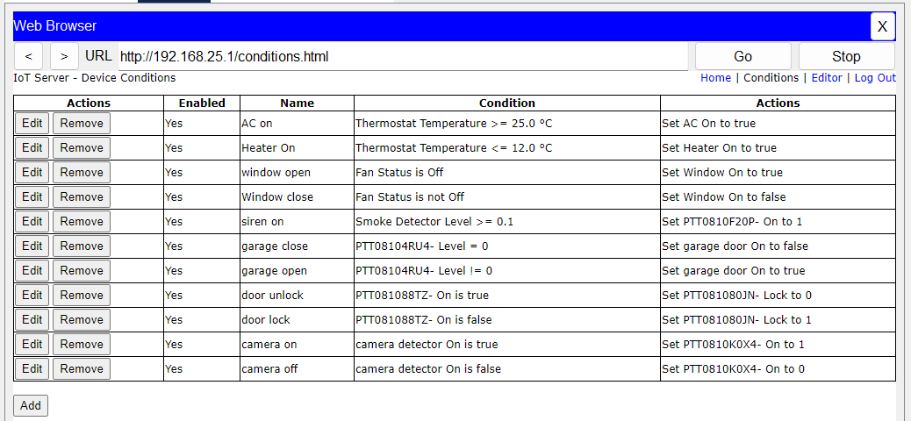

However, the owner also has complete control on the IOT devices.

**Management Offices:**

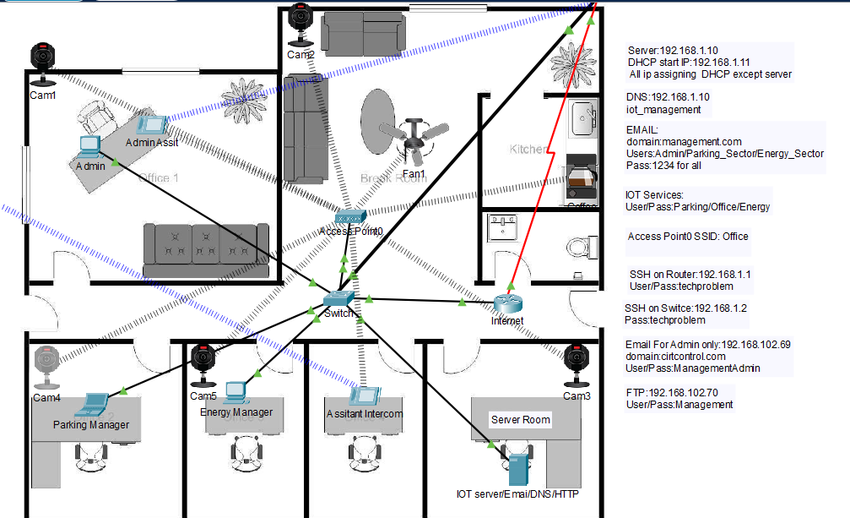

Management Office is interconnected with three clusters Parking, Energy, Internet Service Provider. The services that the server in this cluster provide are as following **HTTP/HTTPS, IOT, DNS, EMAIL, DHCP**. In this cluster through a switch, we have connected to wireless routers one in Parking cluster and other one in Energy cluster. And through a router we have connect this cluster to Internet Service Provider Cluster. This cluster has both wireless and wired connection which are all configured through DHCP. Furthermore, all the configuration for Parking and Energy cluster is done through DHCP.

DHCP Services:

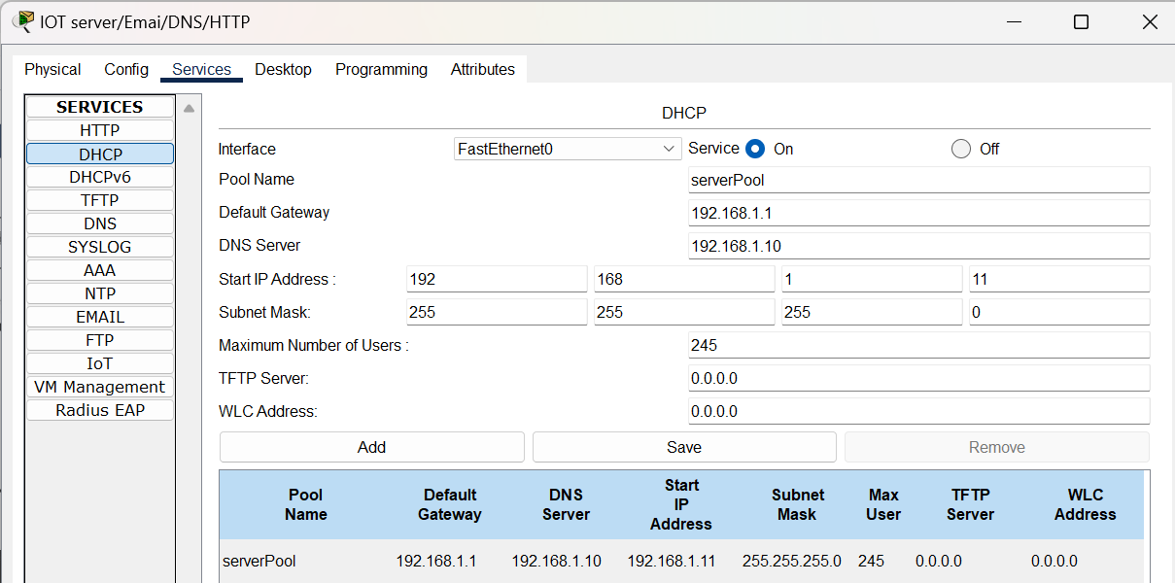

Email Services:

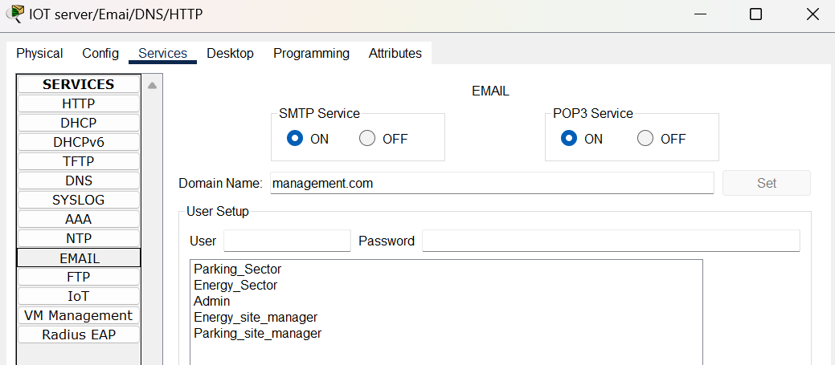

DNS Services:

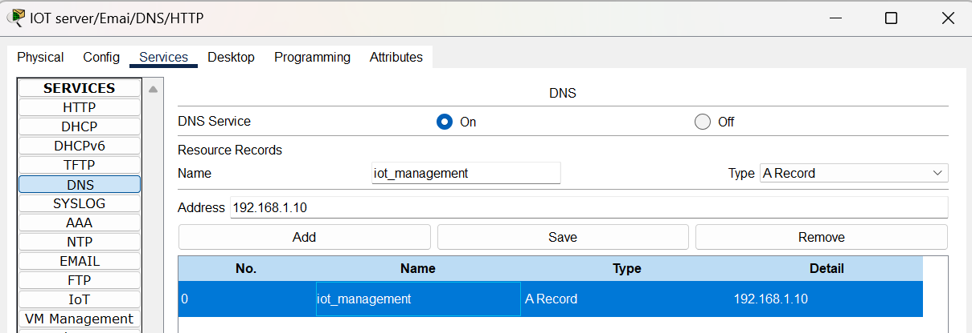

**Energy:**

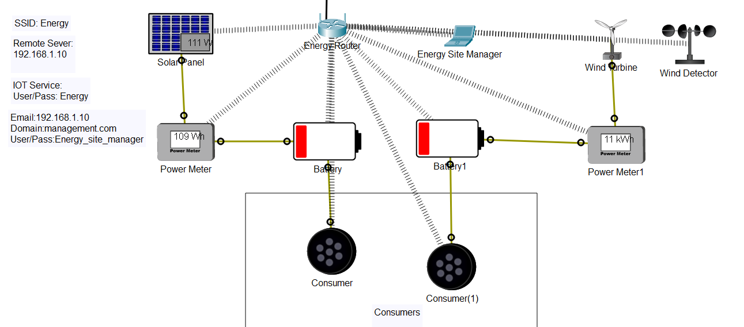

The wireless router in Energy cluster is connected to a switch in Management Office cluster. The **SSID: Energy** for wireless connection of laptops and IOT devices. All the configuration for IOT devices is done through DHCP remote server present in Management Office cluster. The devices are further interconnected using IOT custom cable to show and demonstrate the flow of power generated till end consumer.

**Parking:**

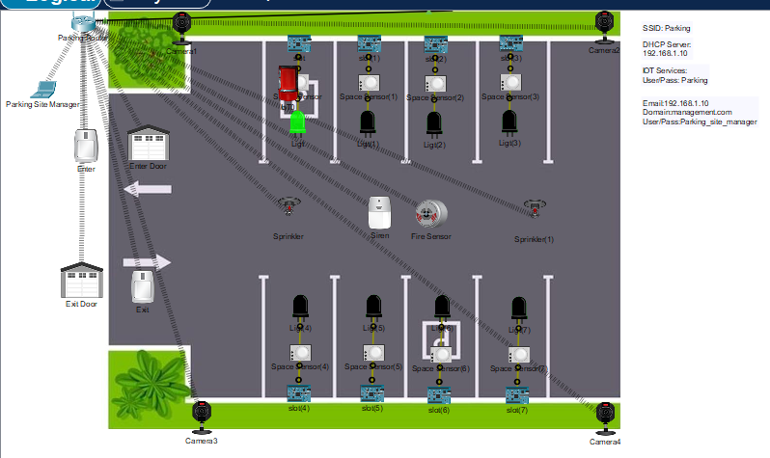

The wireless router in Parking cluster is connected to a switch in Management Office cluster. The **SSID: Parking** for wireless connection of laptops and IOT devices. All the configuration for IOT devices is done through DHCP remote server present in Management Office cluster.

The IOT devices runs on multiple conditions listed below:

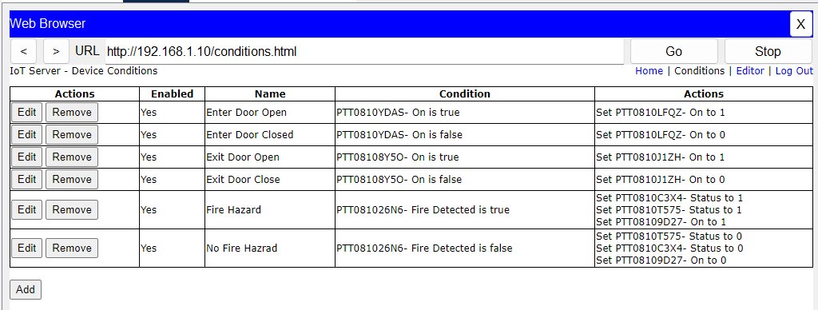

However, what makes this Parking lot smart is it technology that tells from far away whether a car is parked on the spot or not. This is achieved through programming in MCU-board with a motion sensor and light. Code and connection showed below:

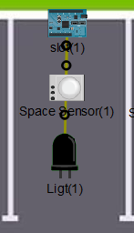 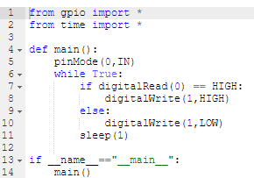

**Server Site:**

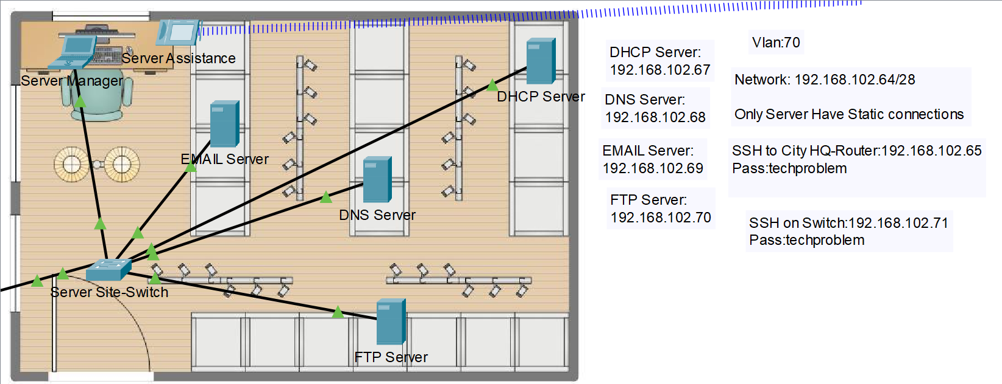

All IP address configuration in this cluster is static. This Server site is part of City Headquarter cluster and the City Headquarter cluster is linked with Other Departments cluster as well as Internet Service Provider. All the linkage is through routers.

The **Network IP** for this cluster is **192.168.102.64/28.** /28 in other words can be considered as **255.255.255.240** meaning that this cluster has only **16 hosts** available.

1. **FTP Server:**

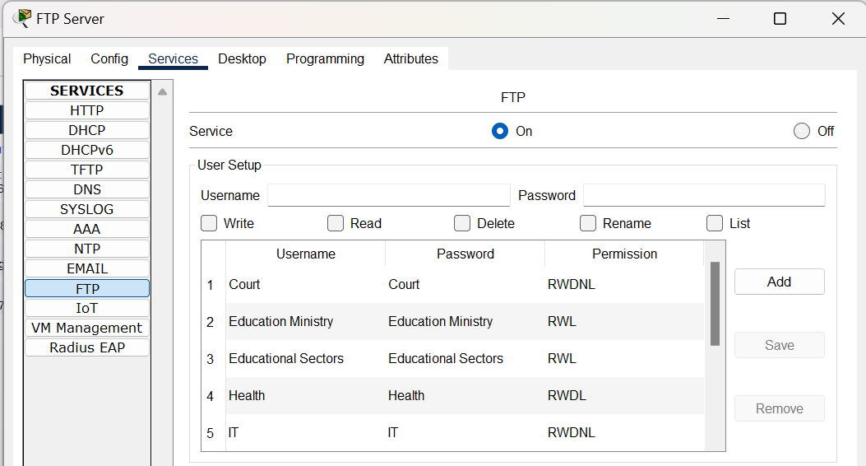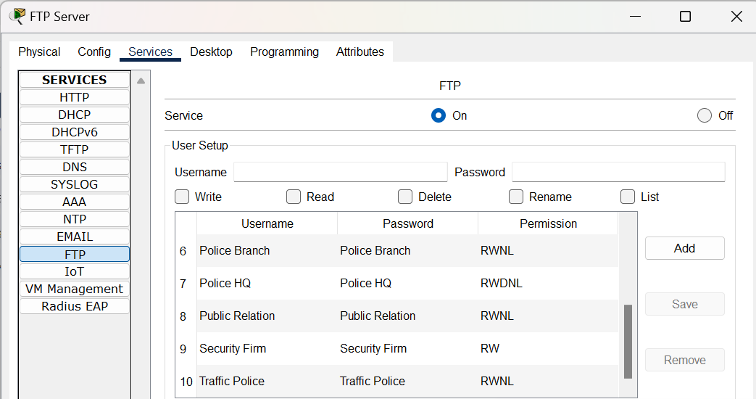

1. **DNS Server:**

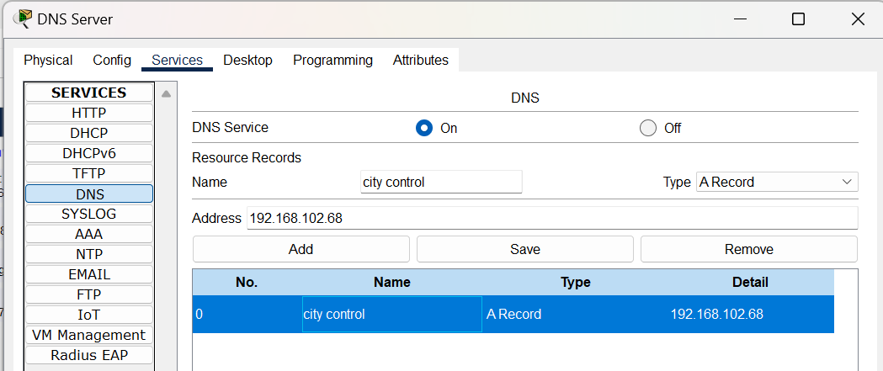

1. **Email Server:** Same User same Password.

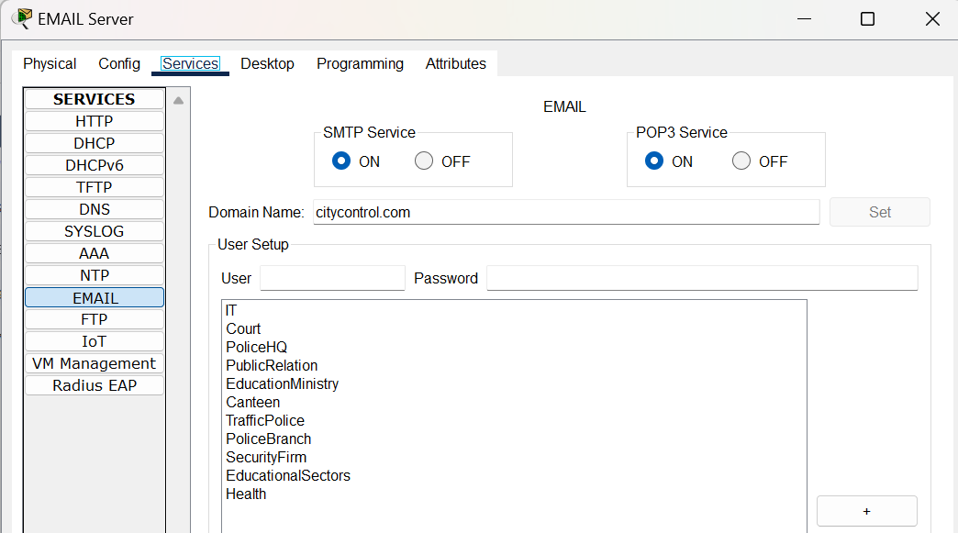

1. **DHCP Server:**

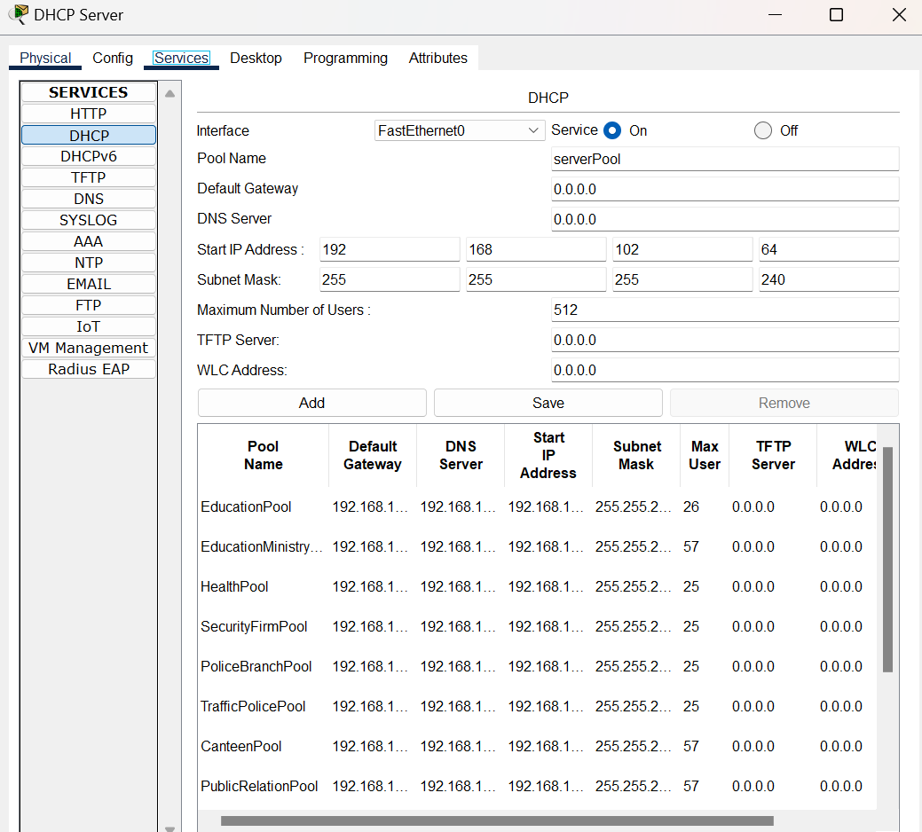

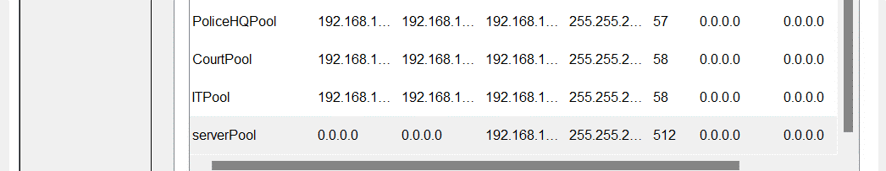

**City Headquarters:**

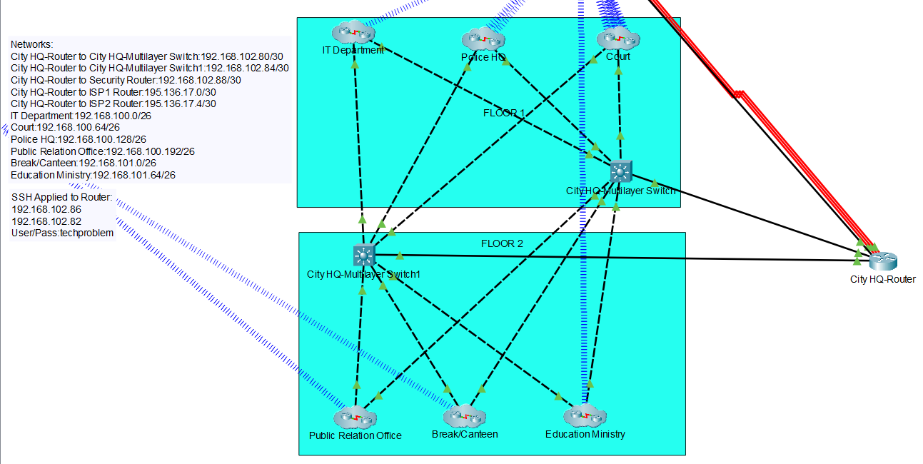

City headquarter cluster contains a router and multilayer to connect different departments which are on different networks. The router is connected with routers in different cluster such as Other Department cluster and Internet Service Provider.

All the IP Address configuration wired or wireless for each network is done through DHCP services activated on DHCP Server in Server Site.

1. **IT Department:** Available Host: 64

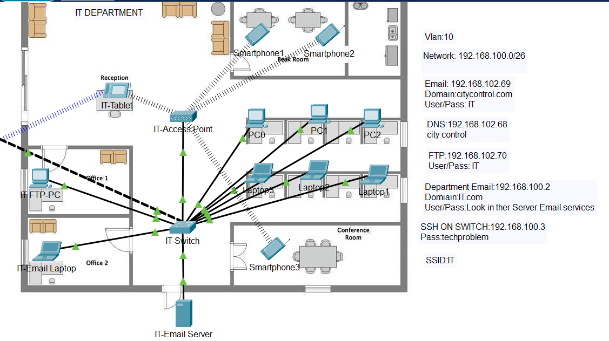

1. **Police HQ:** Available Host: 64

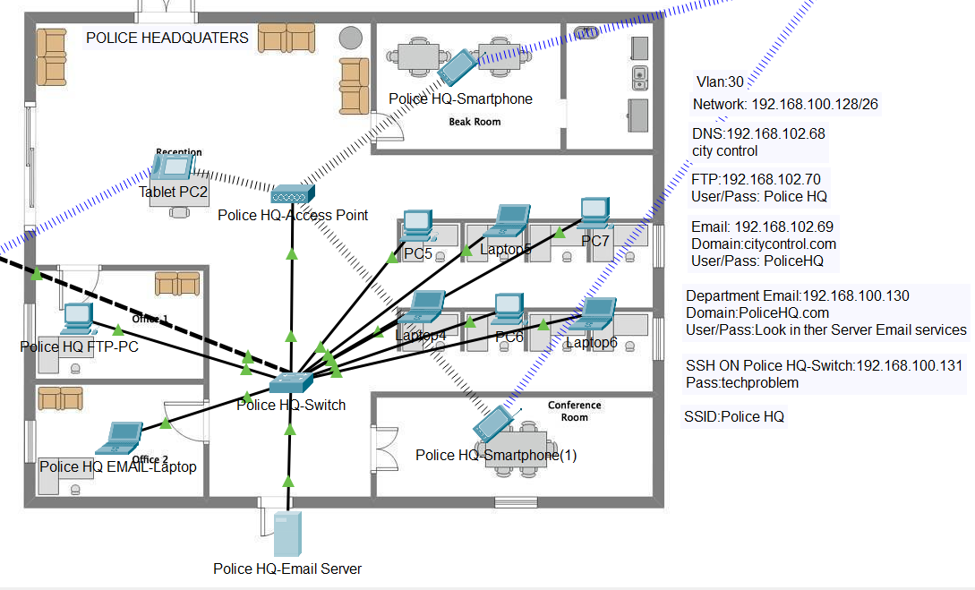

1. **Court:** Available Host: 64

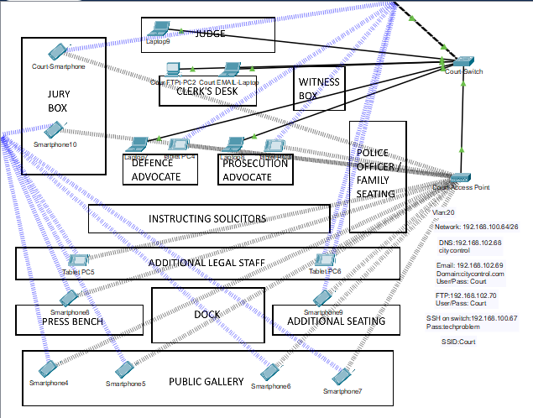

1. **Public Relation Office:** Available Host: 64

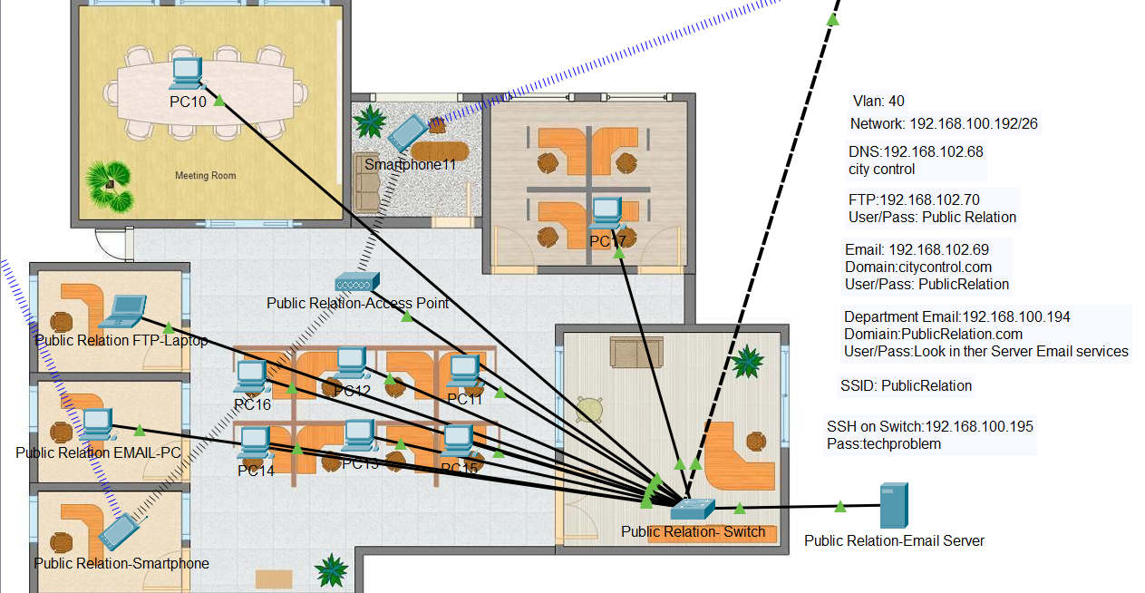

1. **Break/Canteen:** Available Host: 64

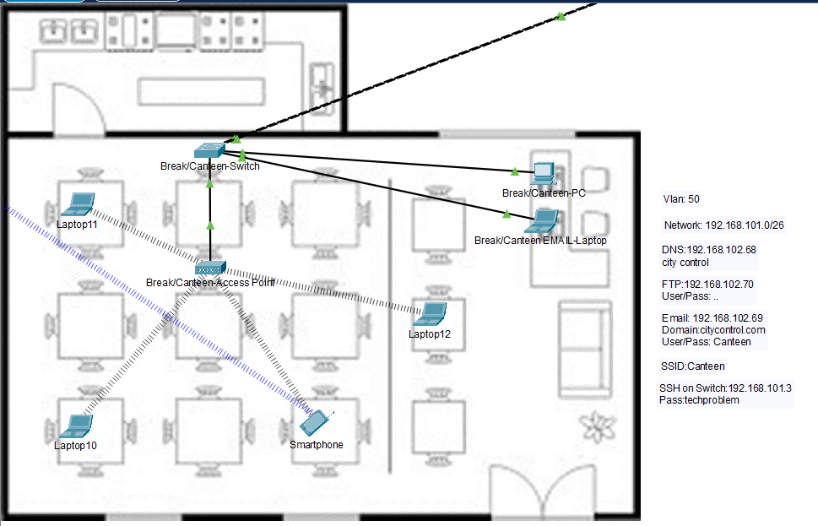

1. **Education Ministry:** Available Host: 64

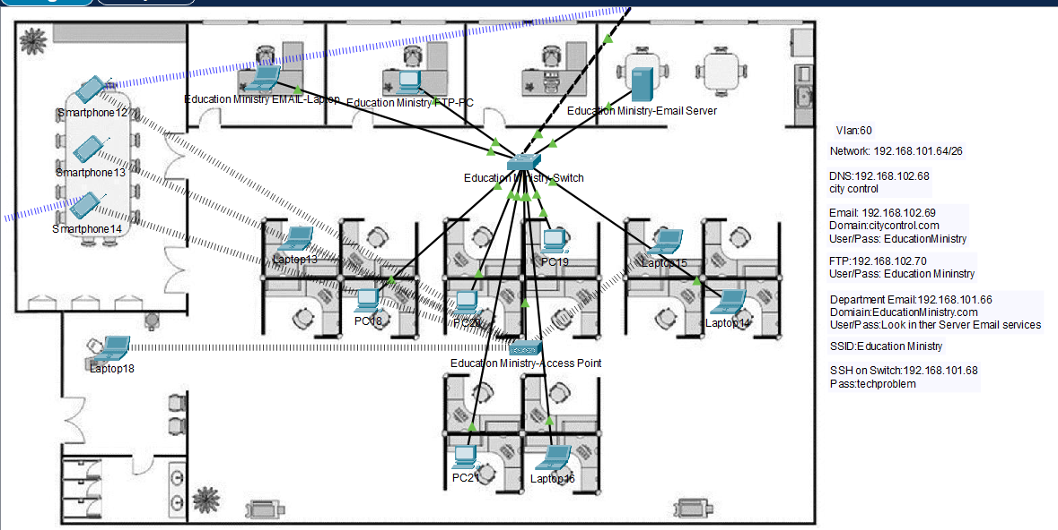

**Other Departments:**

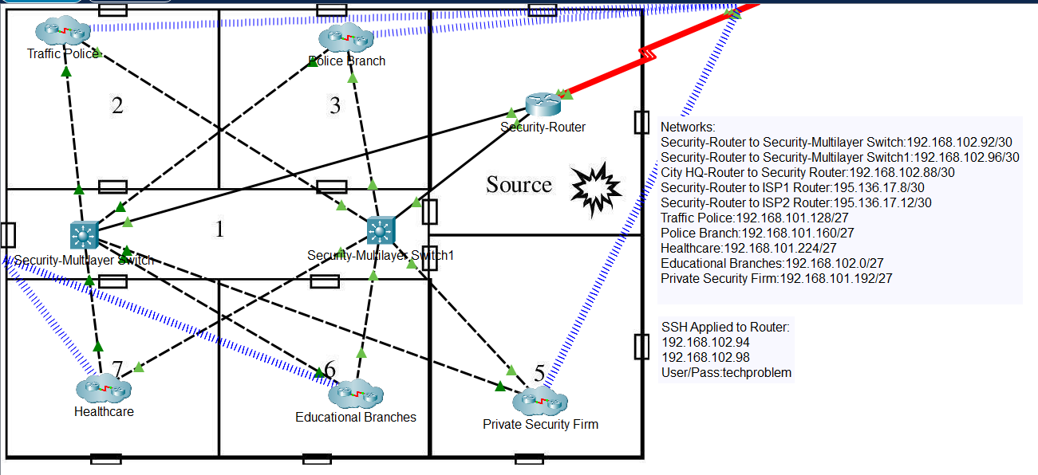

Other Departments cluster contains a router and multilayer to connect different departments which are on different networks. The router is connected with routers in different cluster such as City Headquarters cluster and Internet Service Provider.

All the IP Address configuration wired or wireless for each network is done through DHCP services activated on DHCP Server in Server Site.

1. **Traffic Police:** Available 32 hosts.

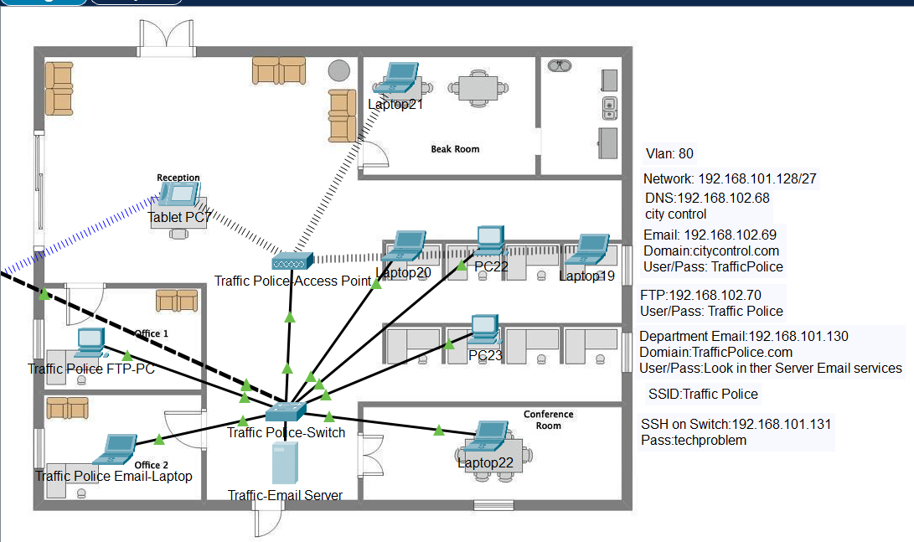

1. **Police Branch:** Available 32 hosts.

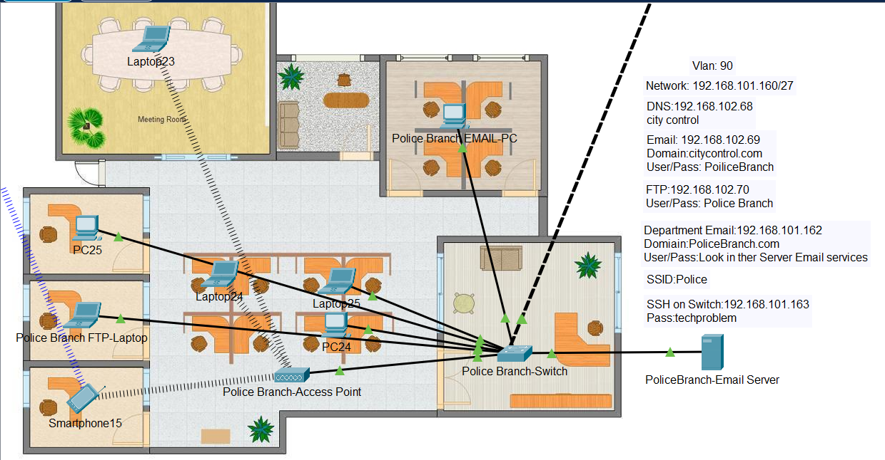

1. **Educational Branches:** Available 32 hosts.

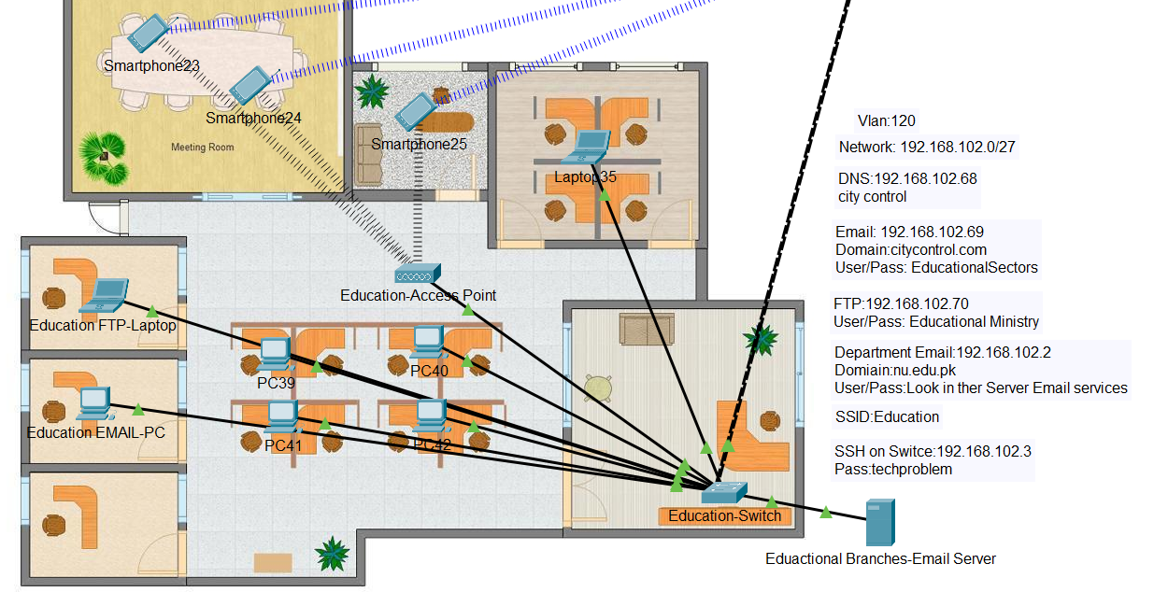

1. **Healthcare:** Available 32 hosts.

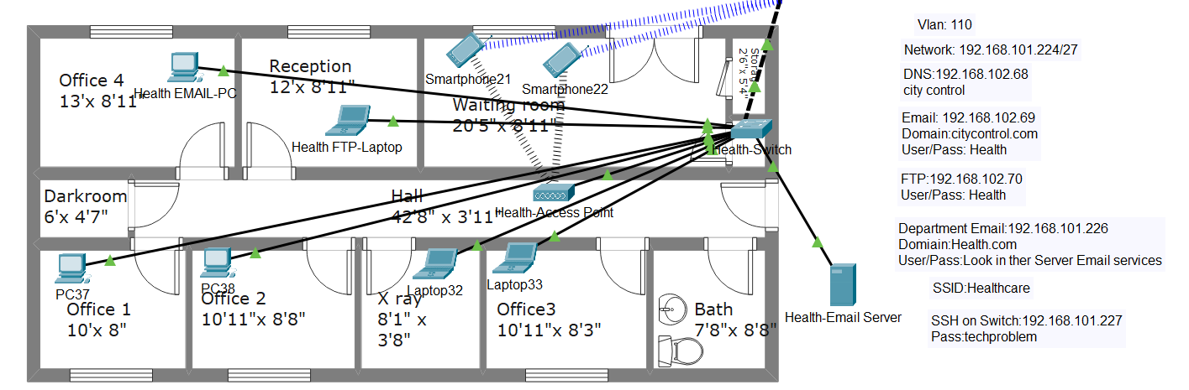

1. **Private Security Firm:** Available 32 hosts.

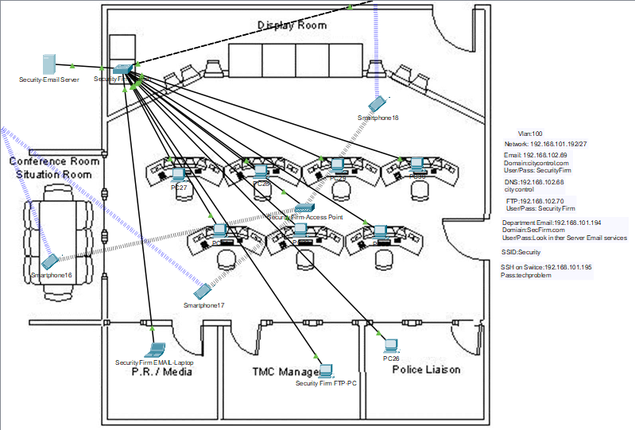

**Extra Info City Headquarter /Other Departments/Server Site:**

To Provide a seamless communication between the different clusters we have created vlan database and have done inter vlan routing cli attached below:

VLAN on Switches:

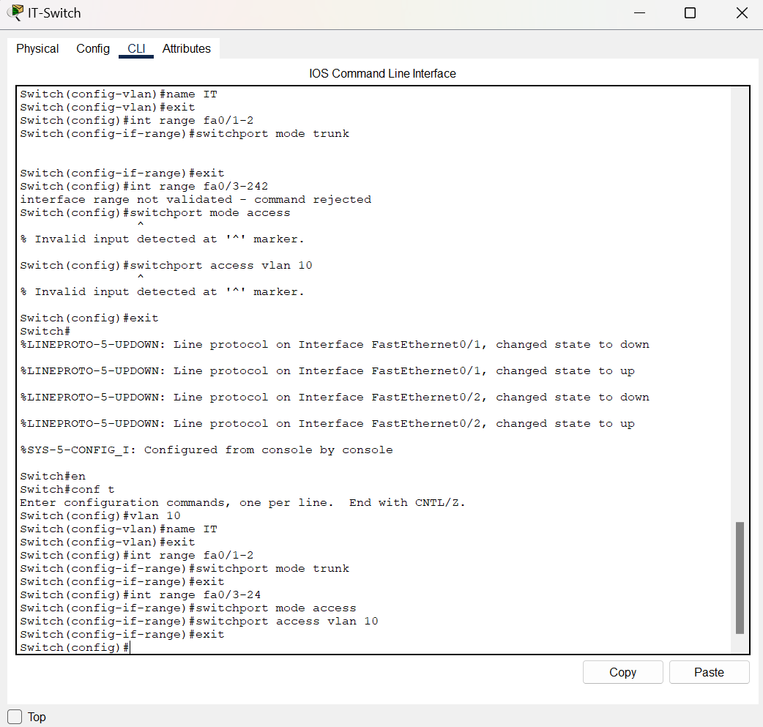

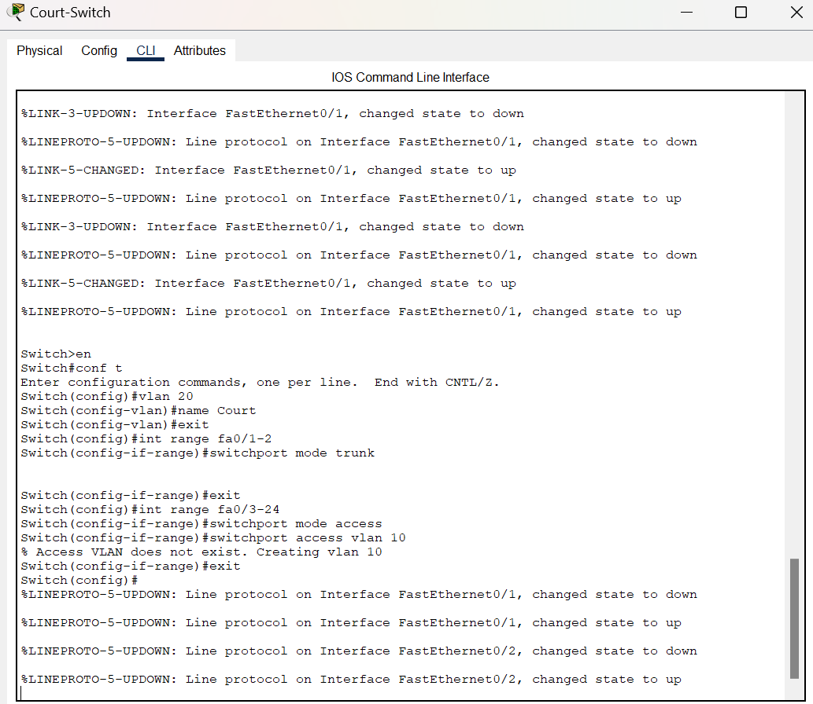

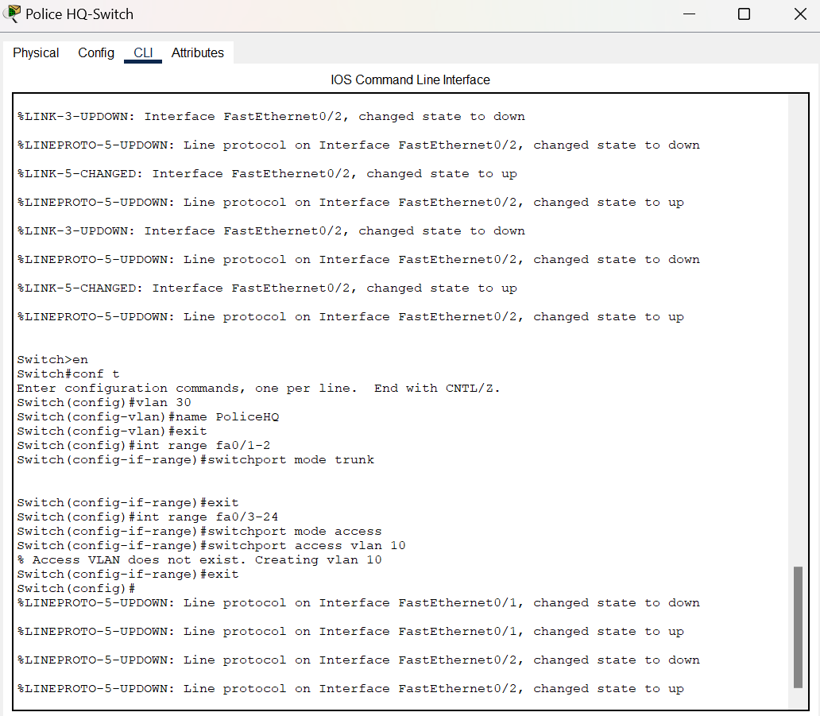

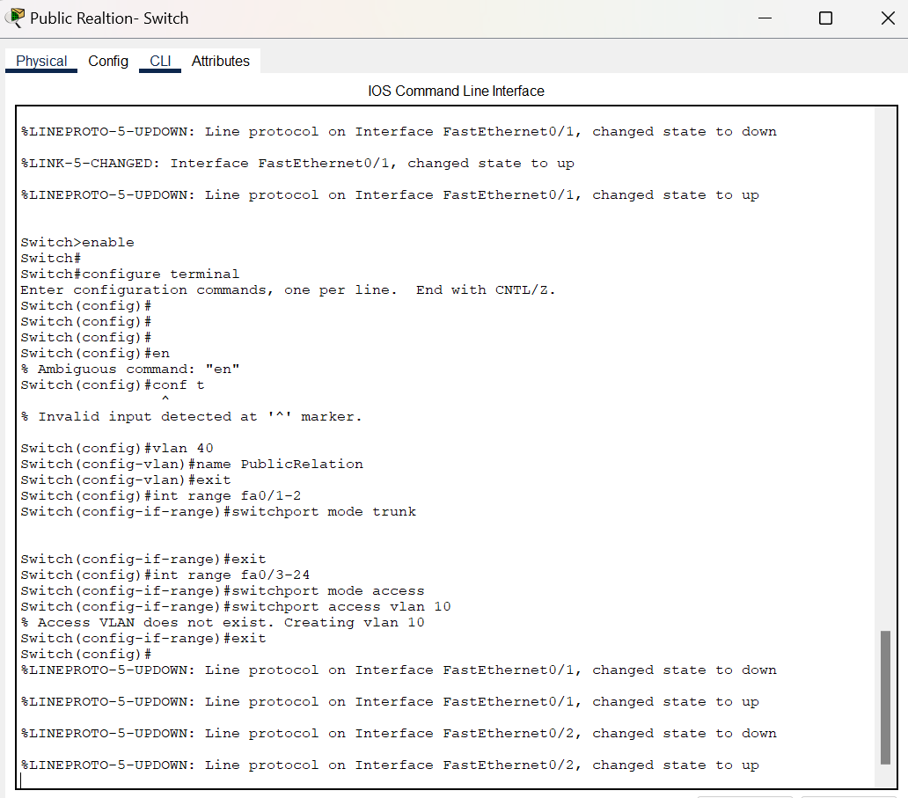

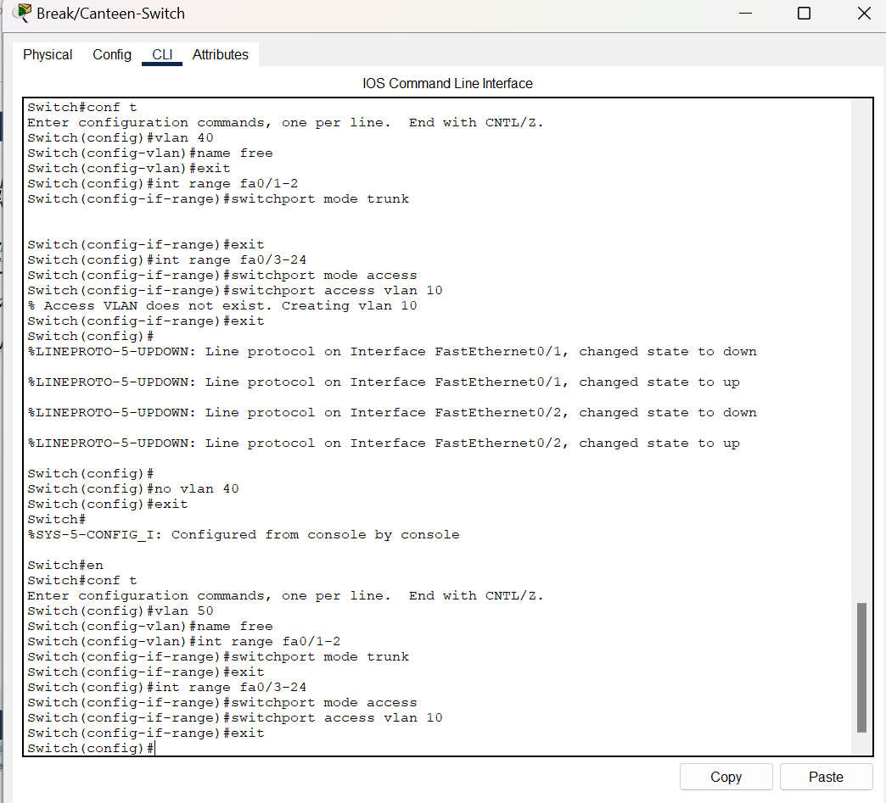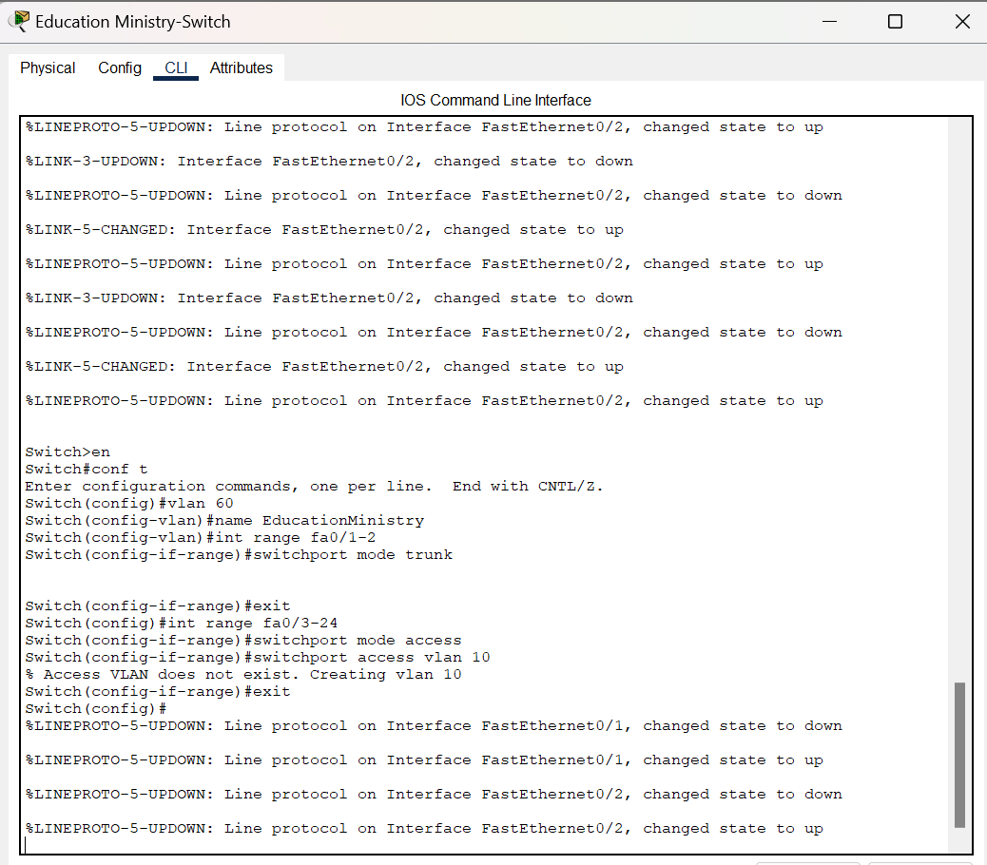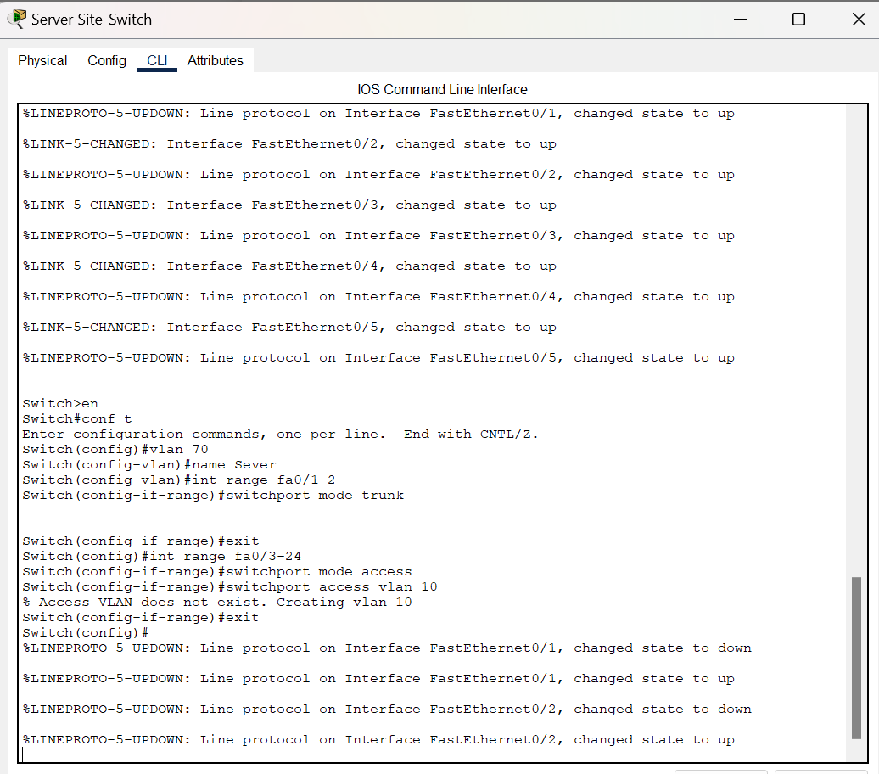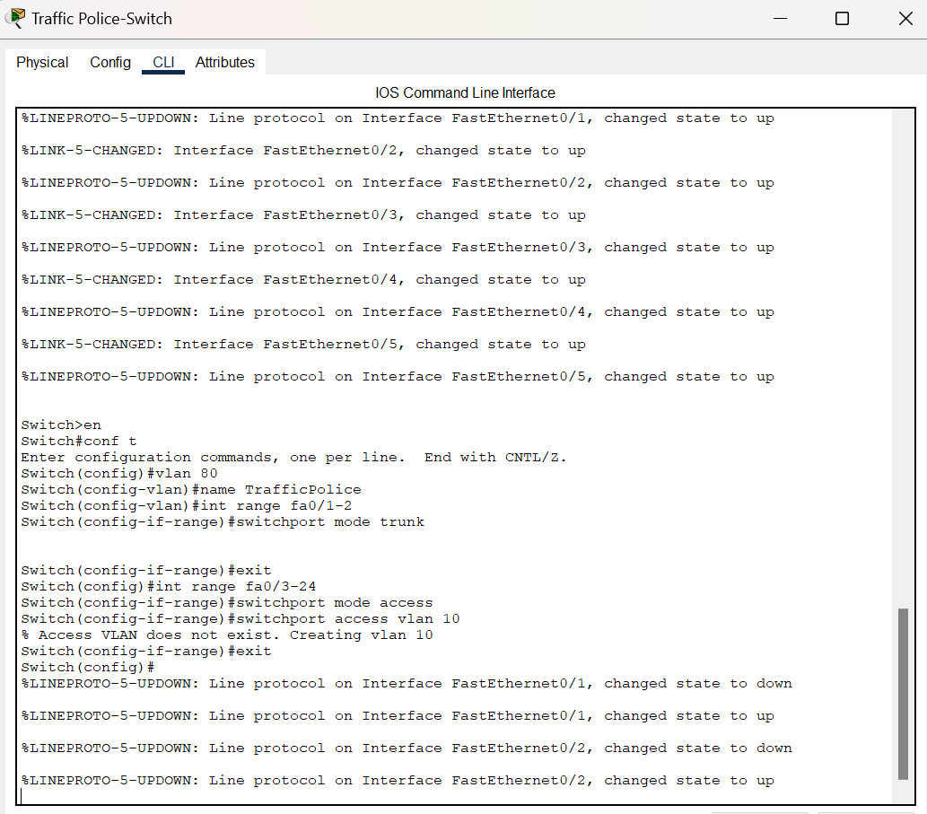

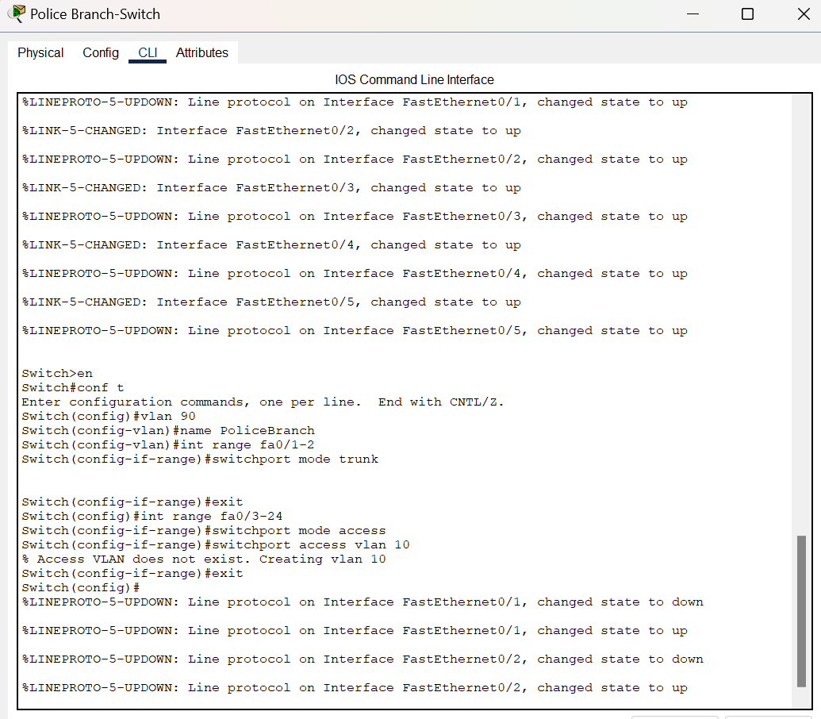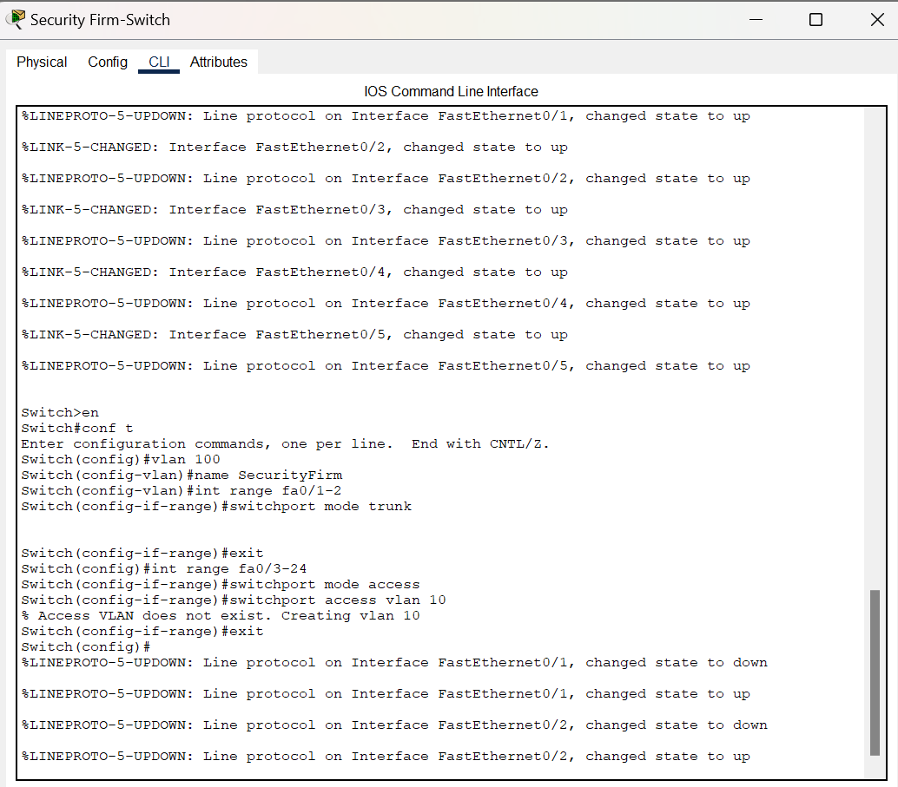

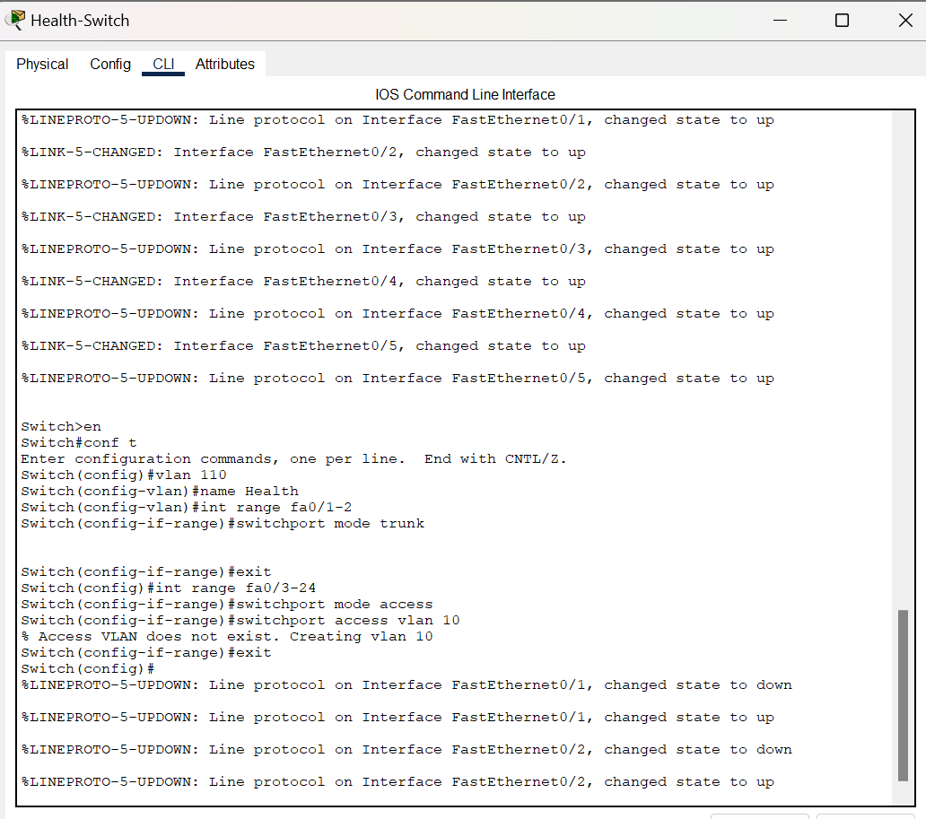

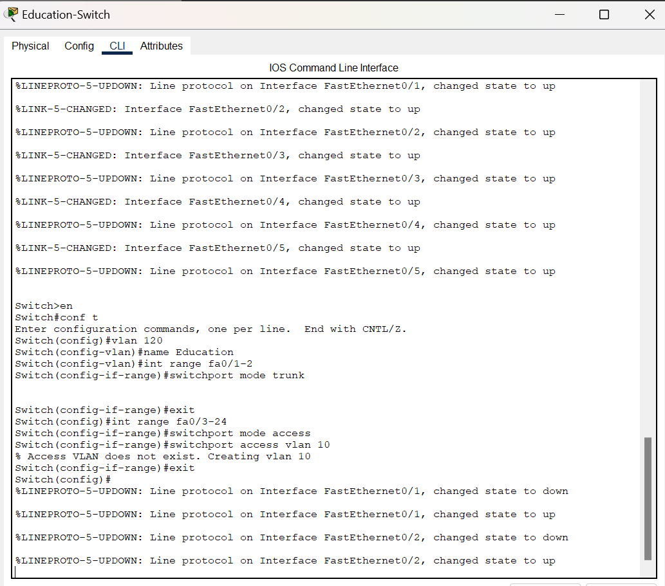

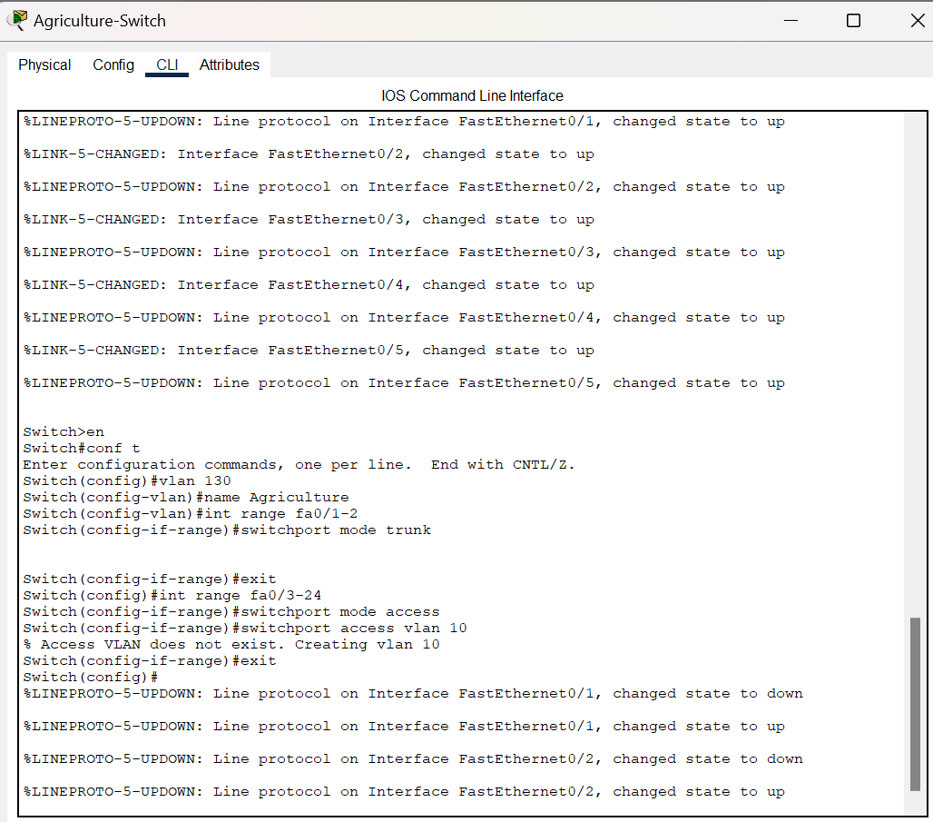

VLAN to Multilayer-Switch:

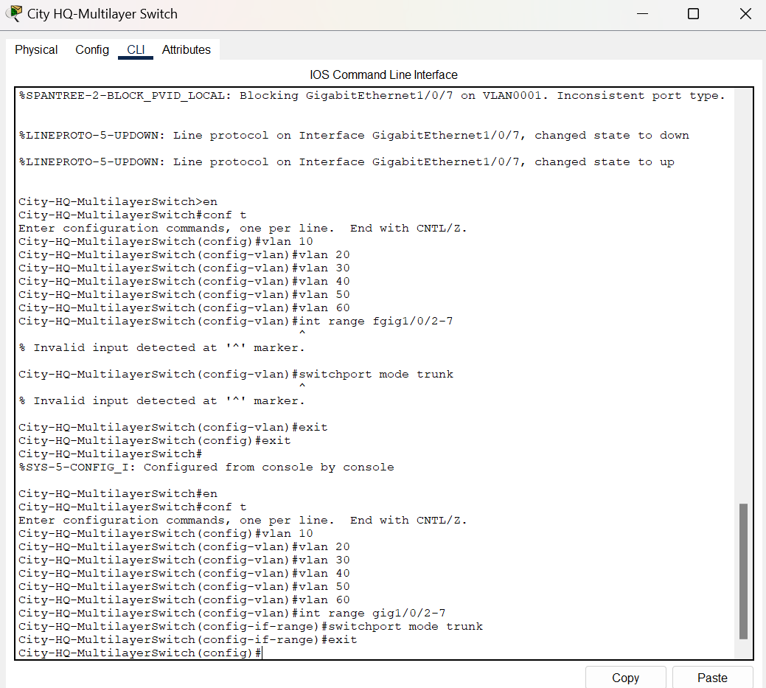

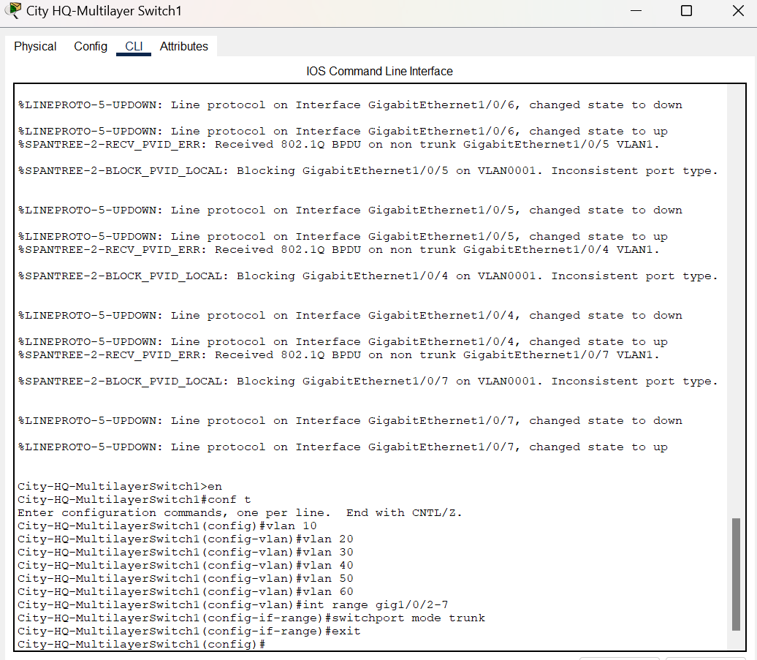

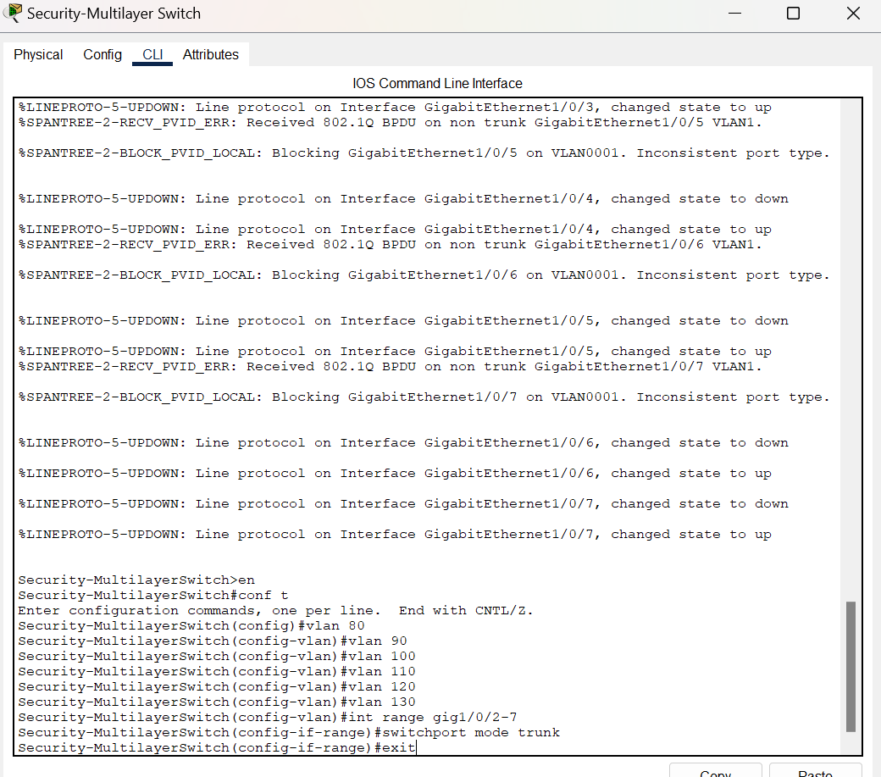

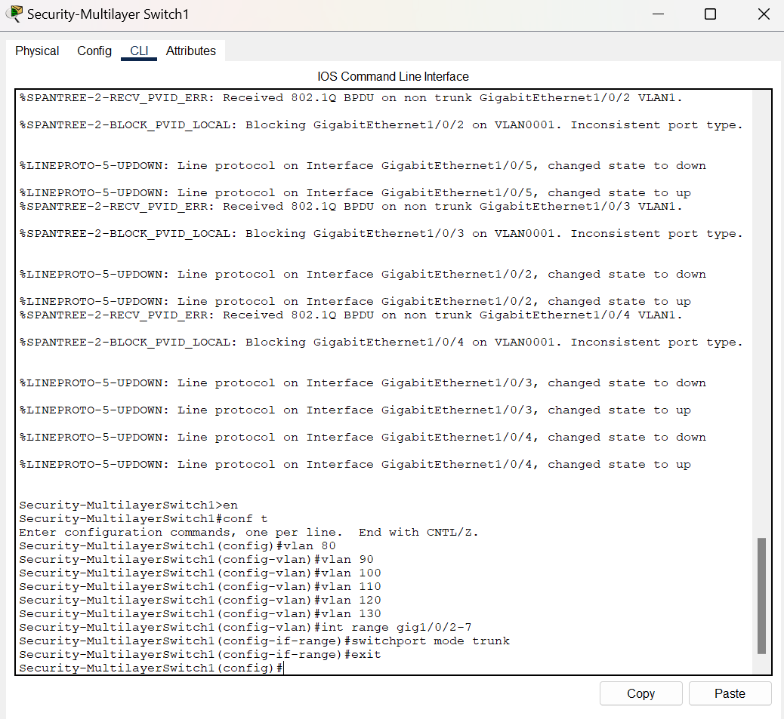

Inter-Vlan Routing on Multilayer Switches:

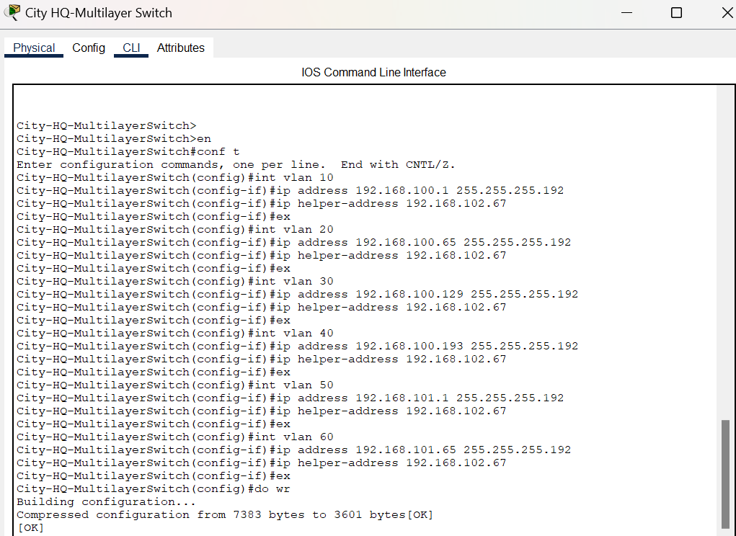

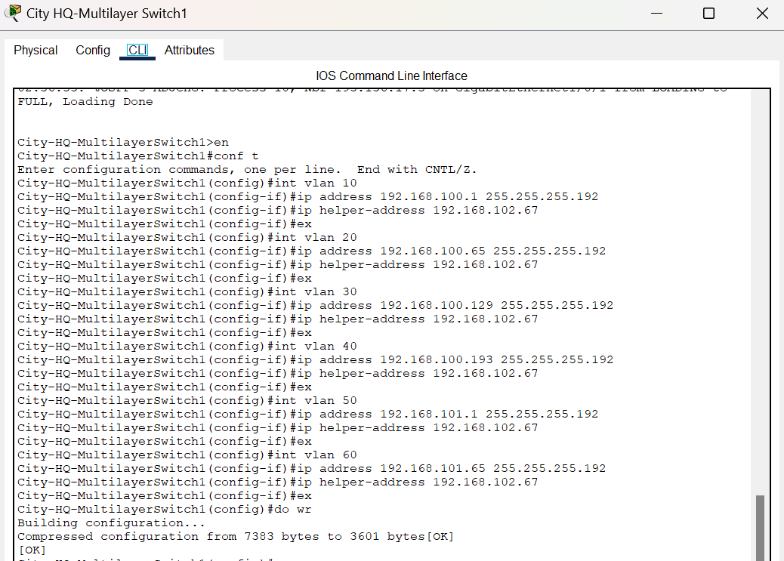

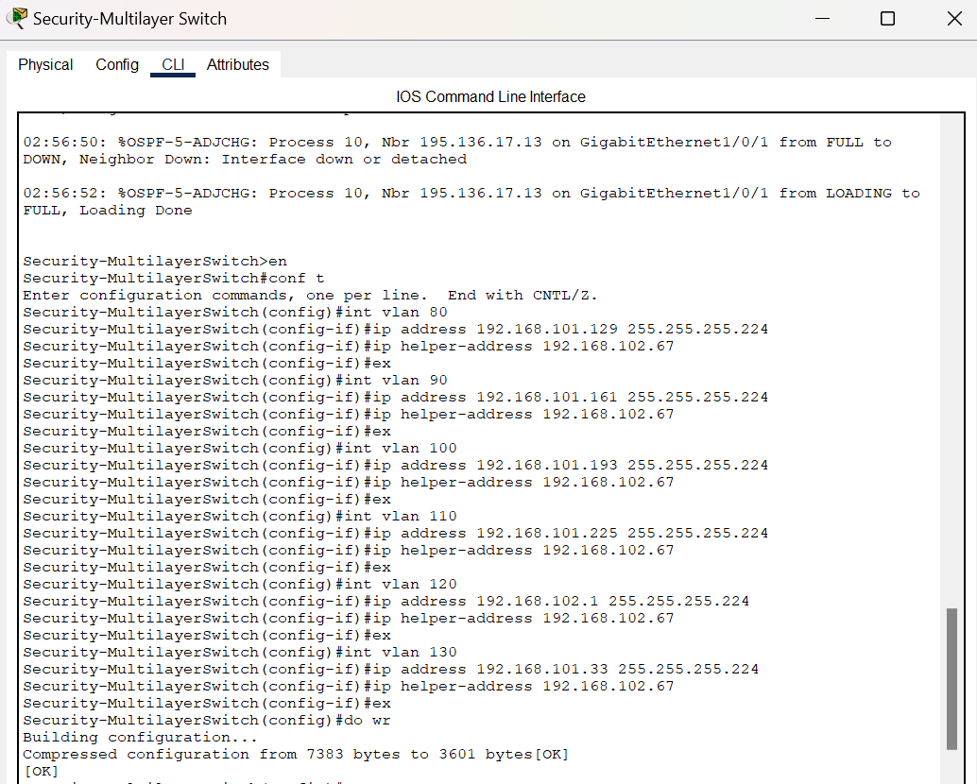

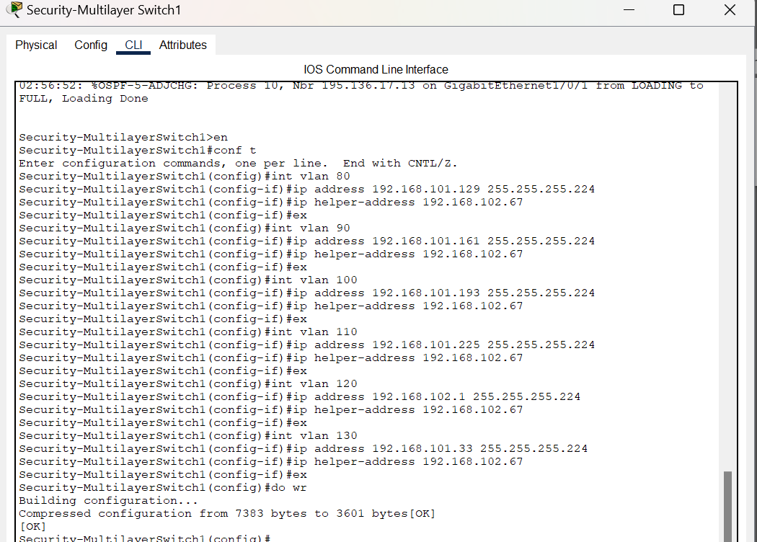

**Internet Service Provider:**

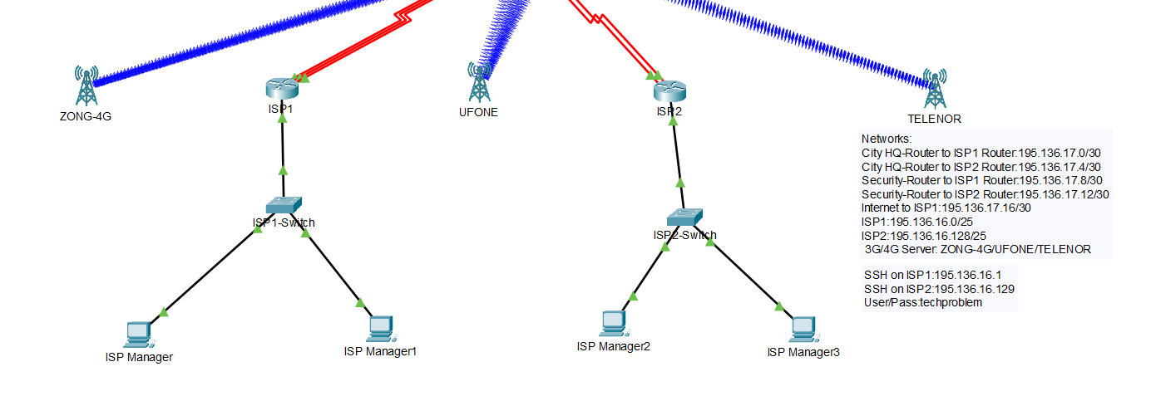

Internet Service Provider is basically a source that provides internet to the whole city. It is connected to Management Office, City Headquarters, Other Departments.

City Headquarters, Other Departments are connected to both the ISP routers meaning that if one happens to be down the communication still runs smoothly. However, the Management Office is connected to only one ISP meaning that if one ISP is down the internet is down and problem in communication.

All the connection for ISP is done through DHCP services without any DHCP server being presents. The router is configured is such a way that it creates its own server pool.

And all the devices that require 3G or 4G connection is connected to the cell tower according to their provider.

DHCP on ISP Routers:

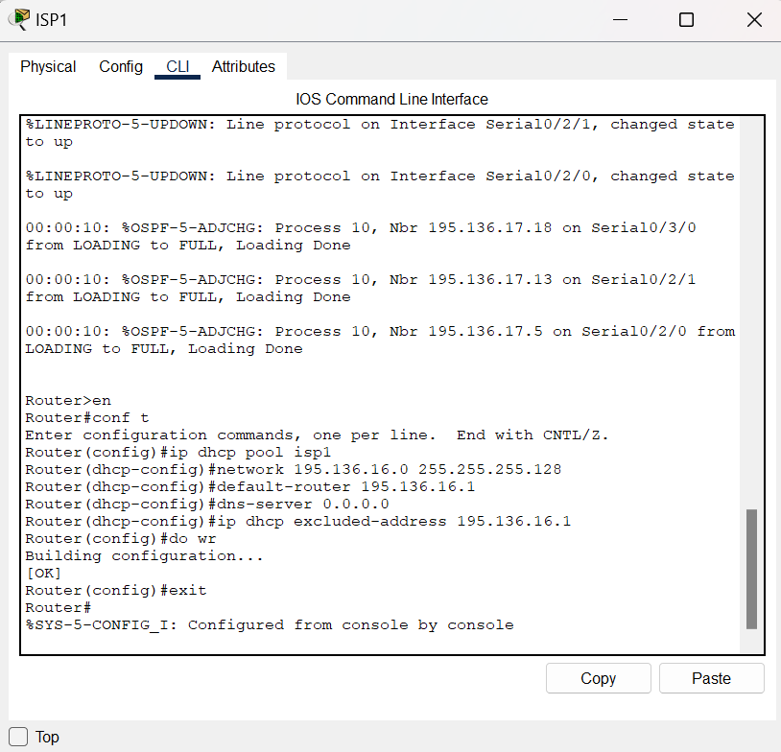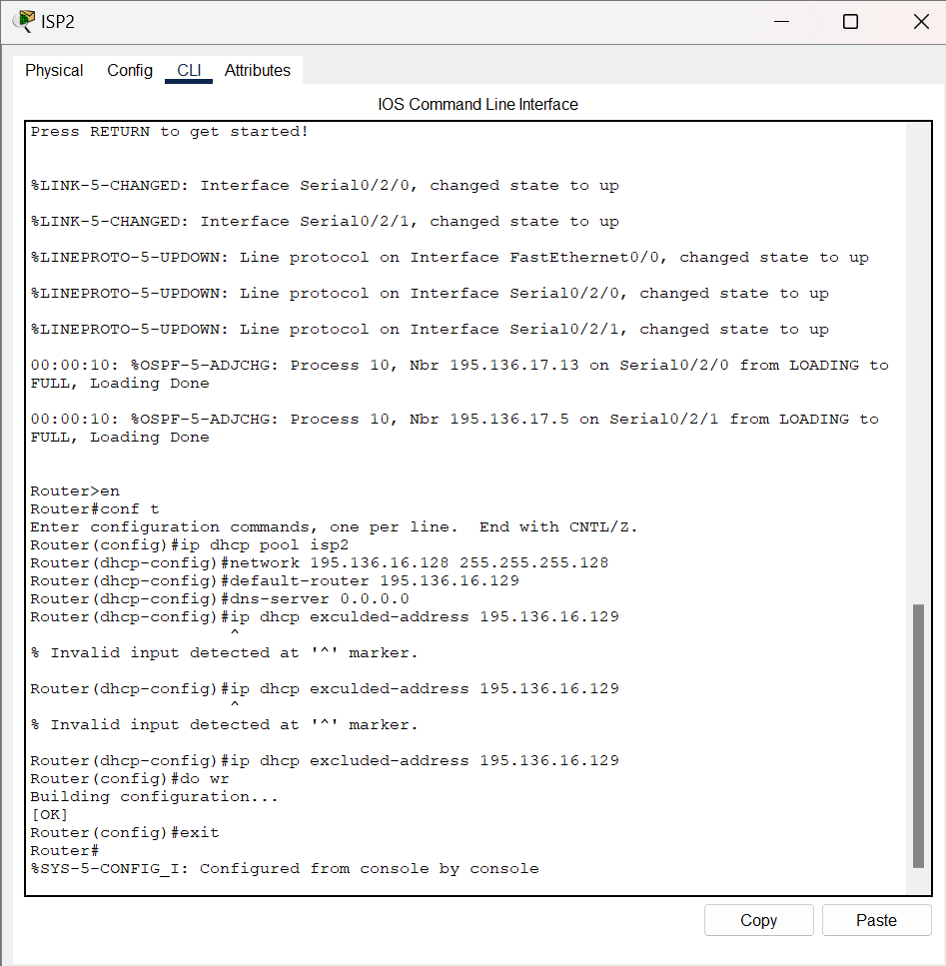

**Some More Configuration Done Through CLI:**

SSH on Multilayer Switches:

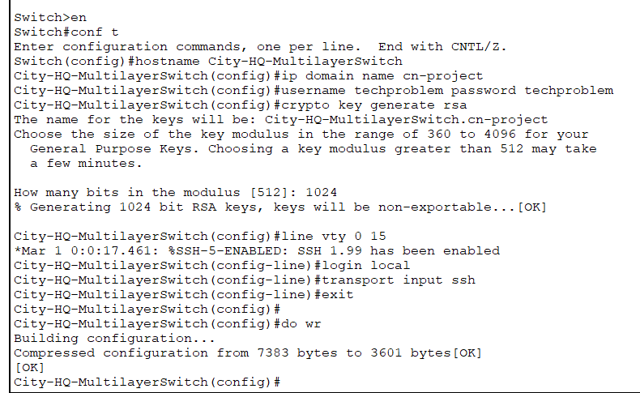

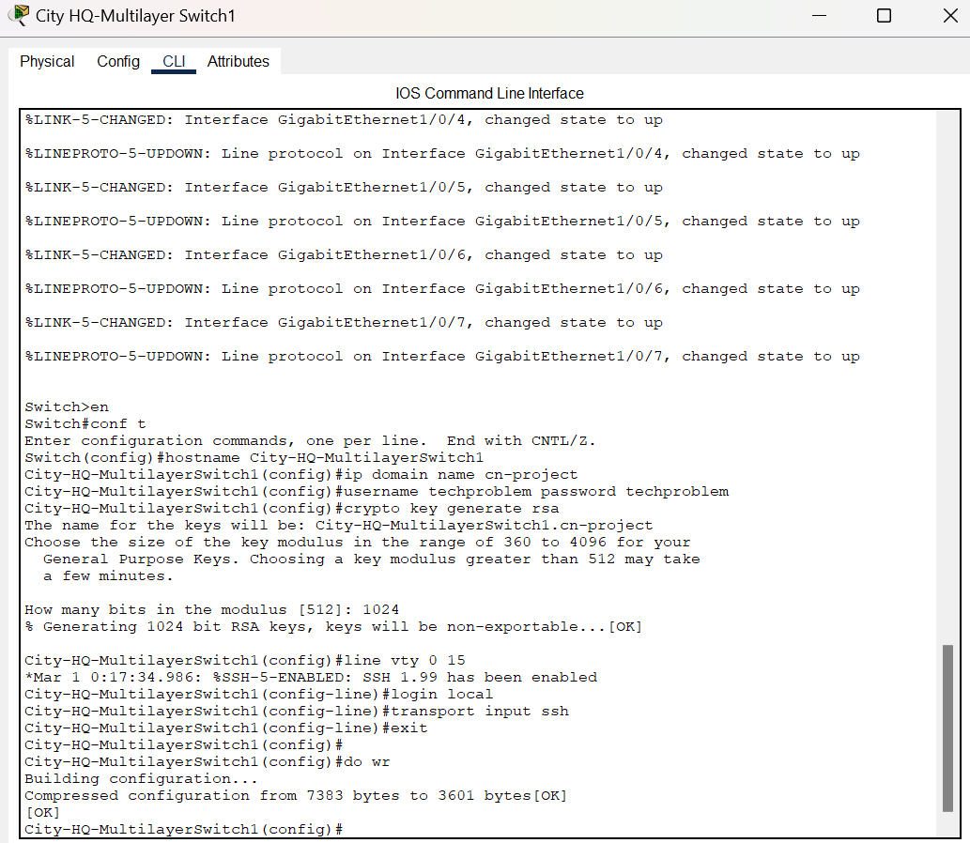

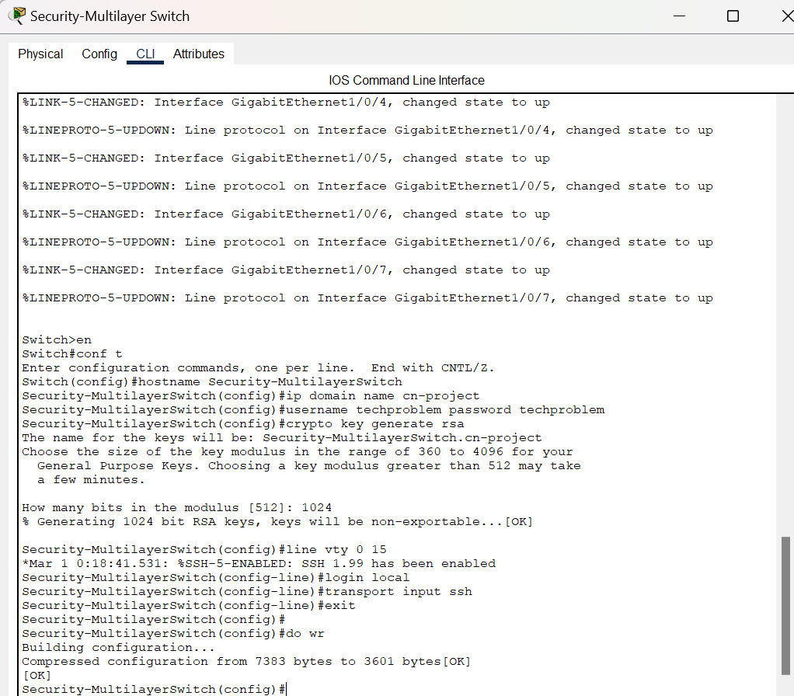

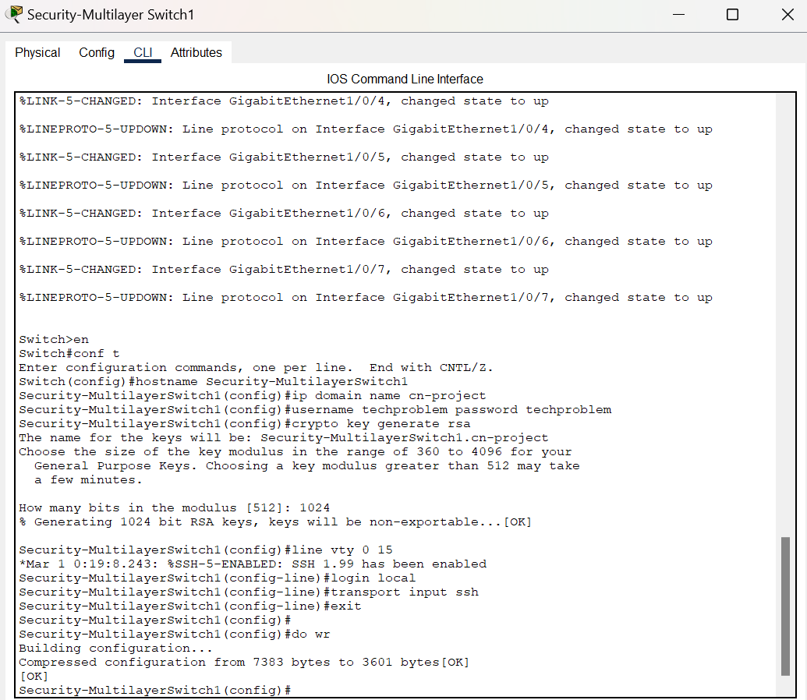

SSH on Routers:

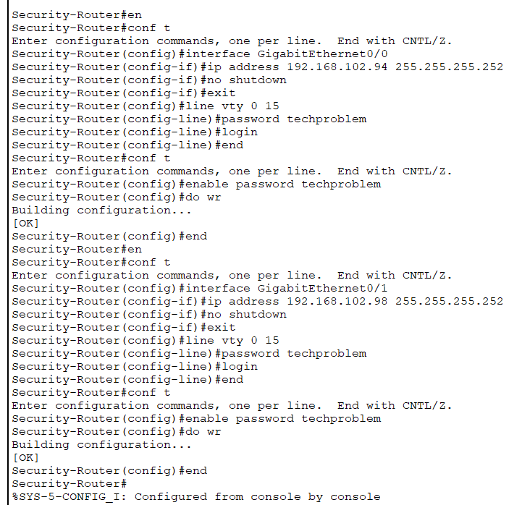

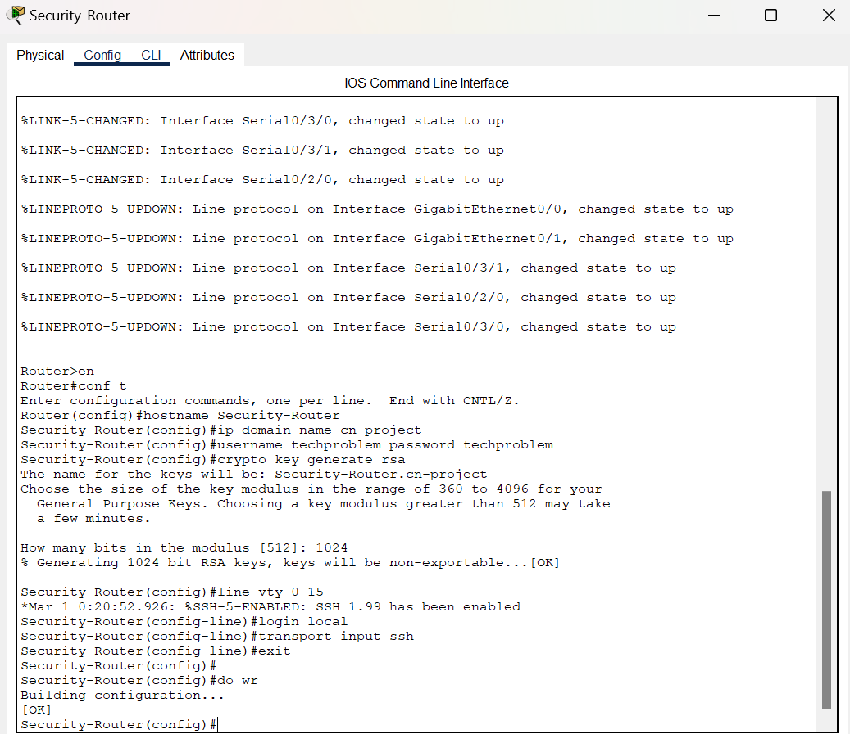

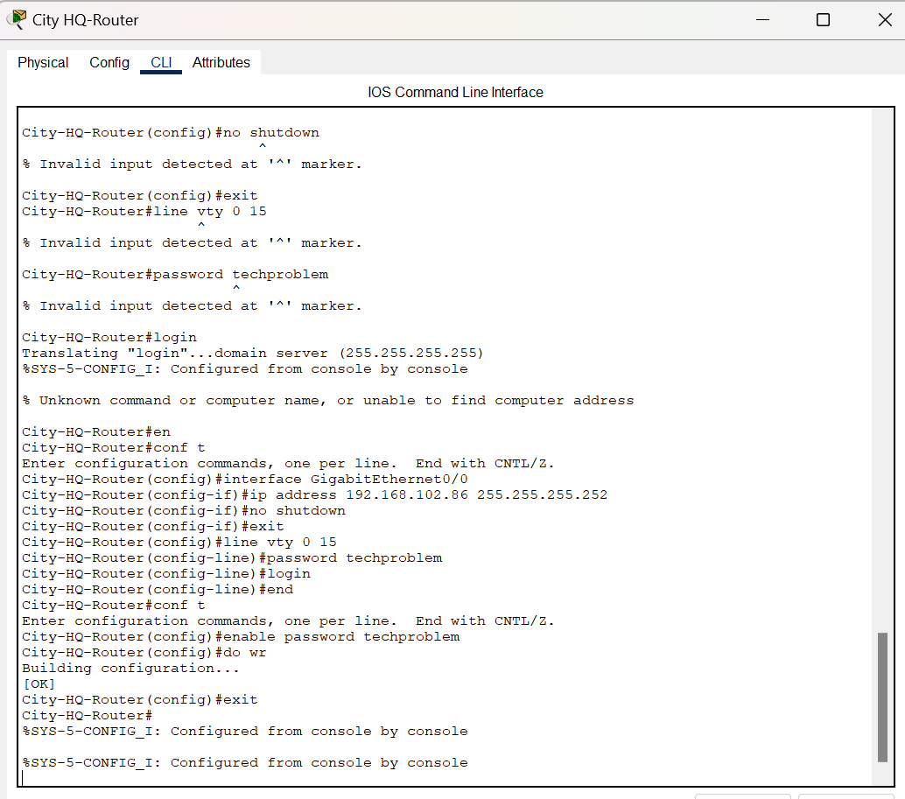

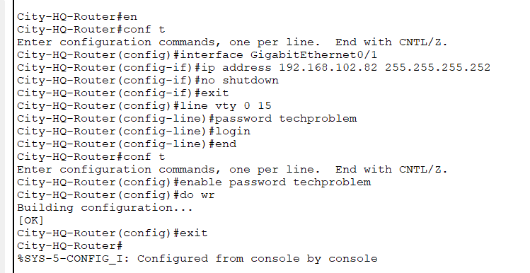

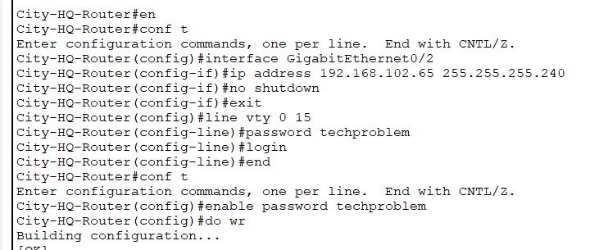

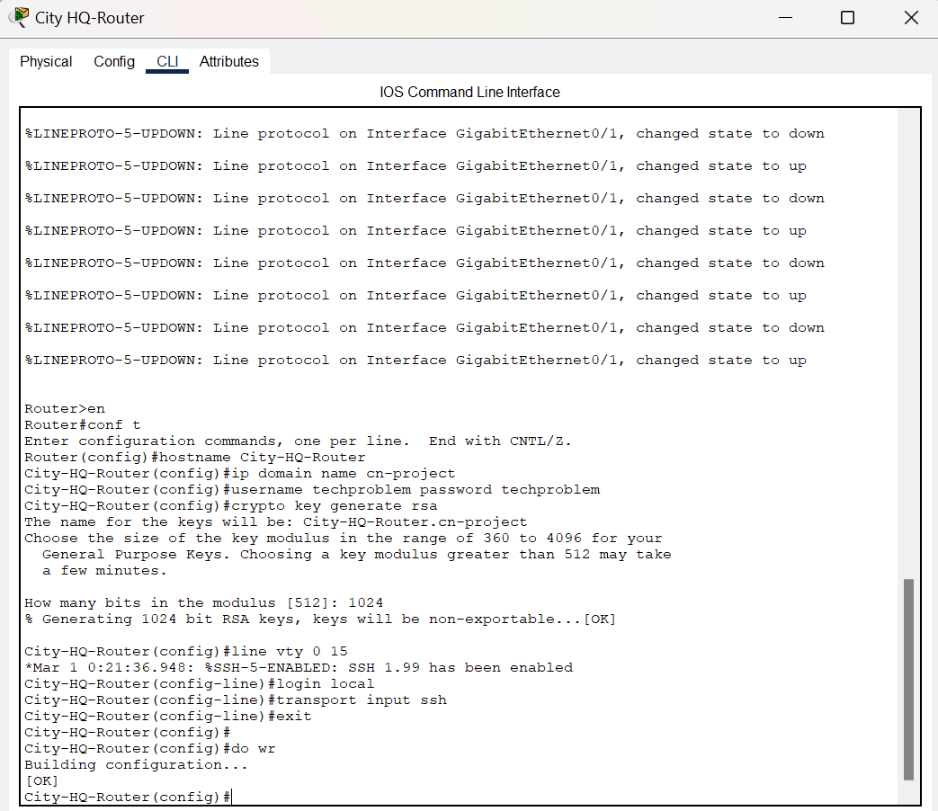

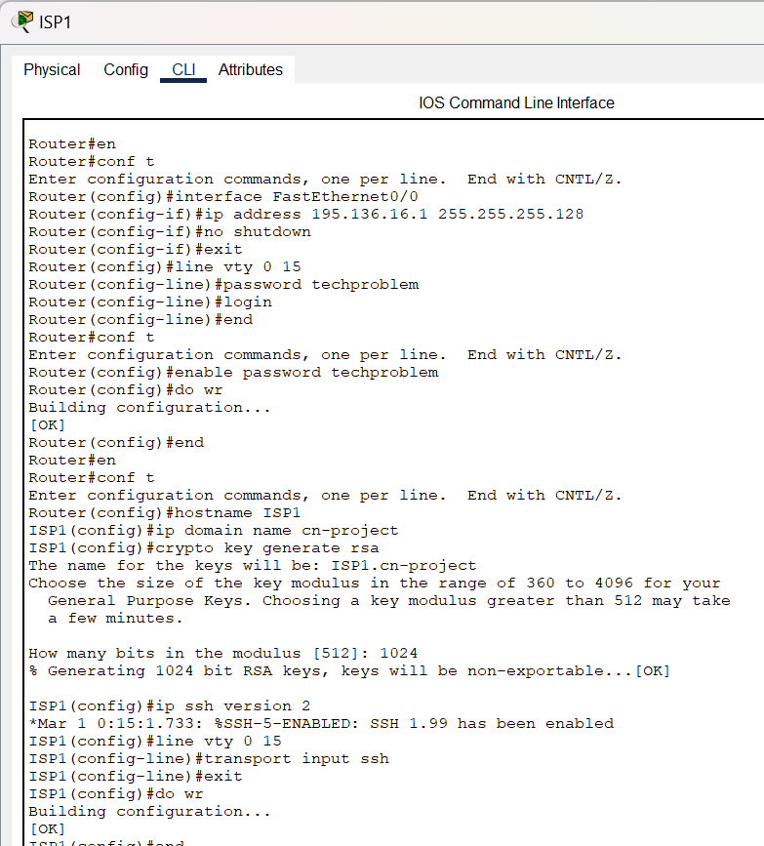

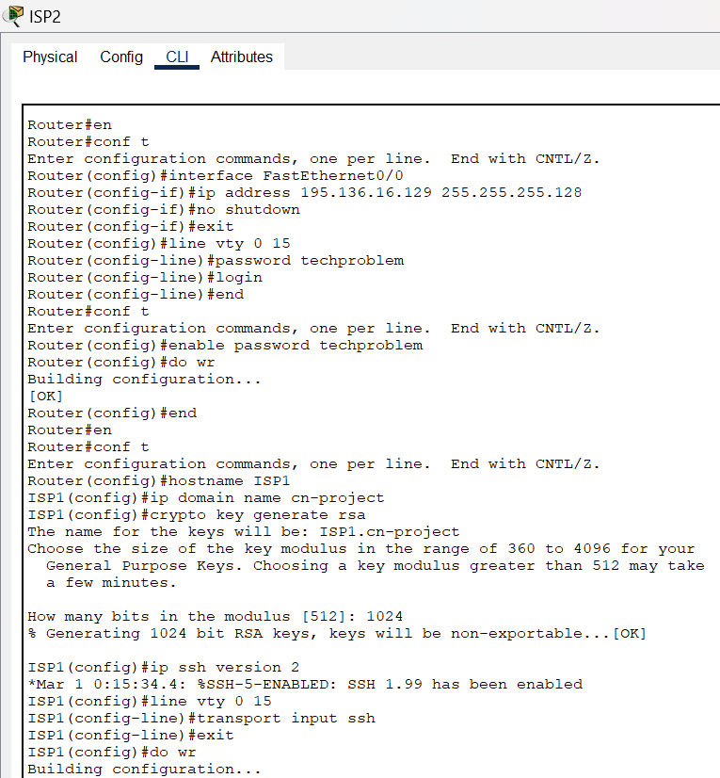

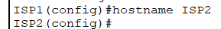

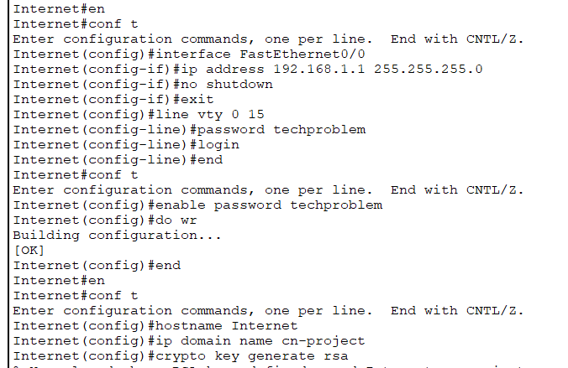

SSH on Switches:

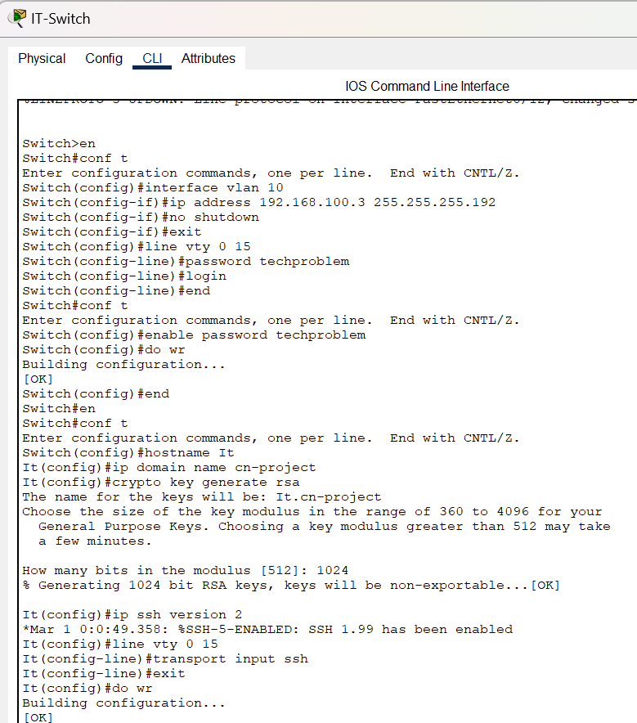

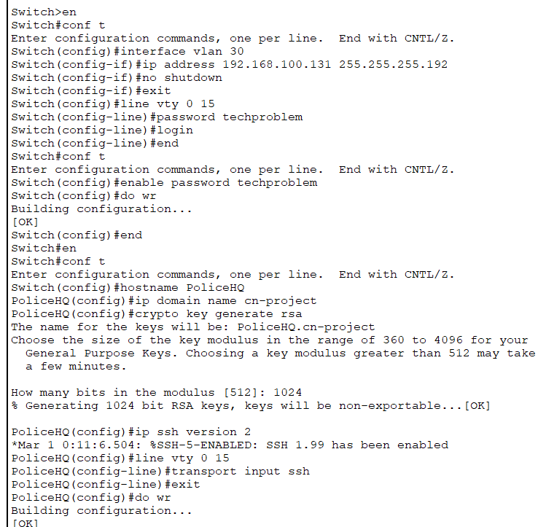

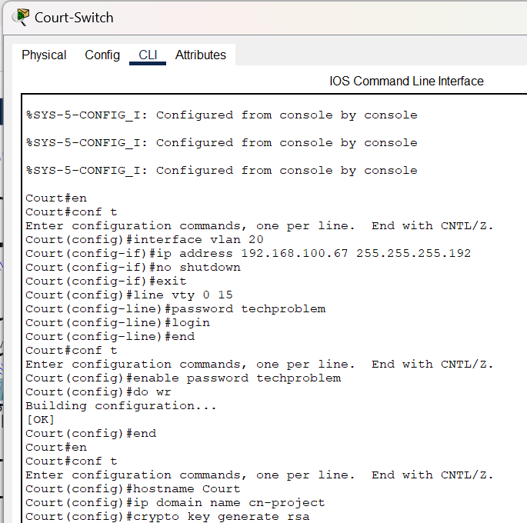

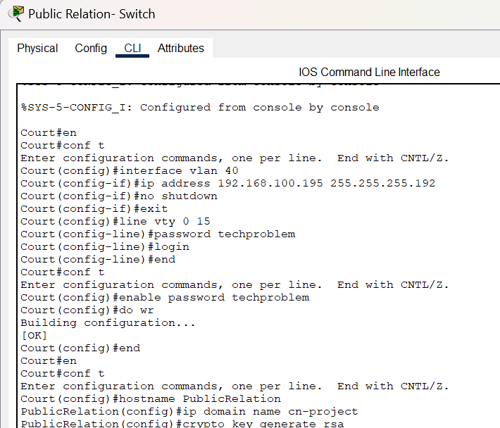

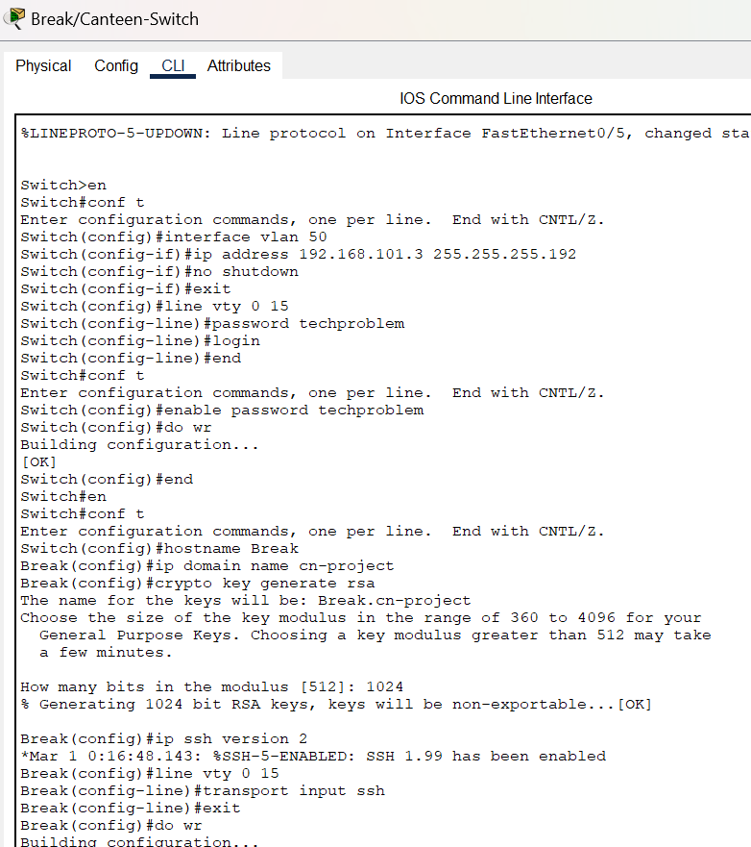

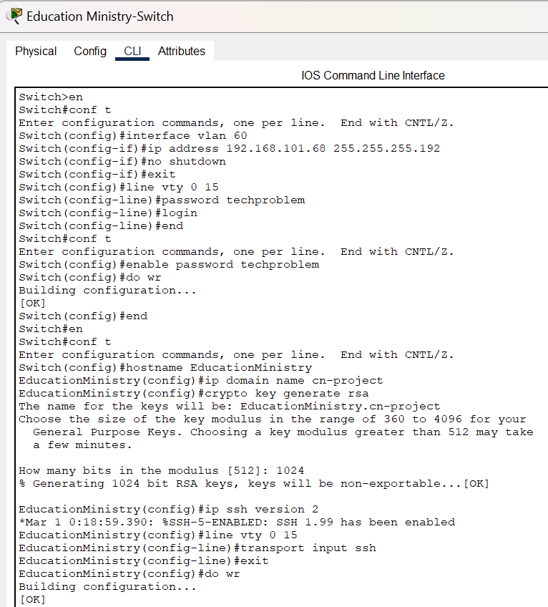

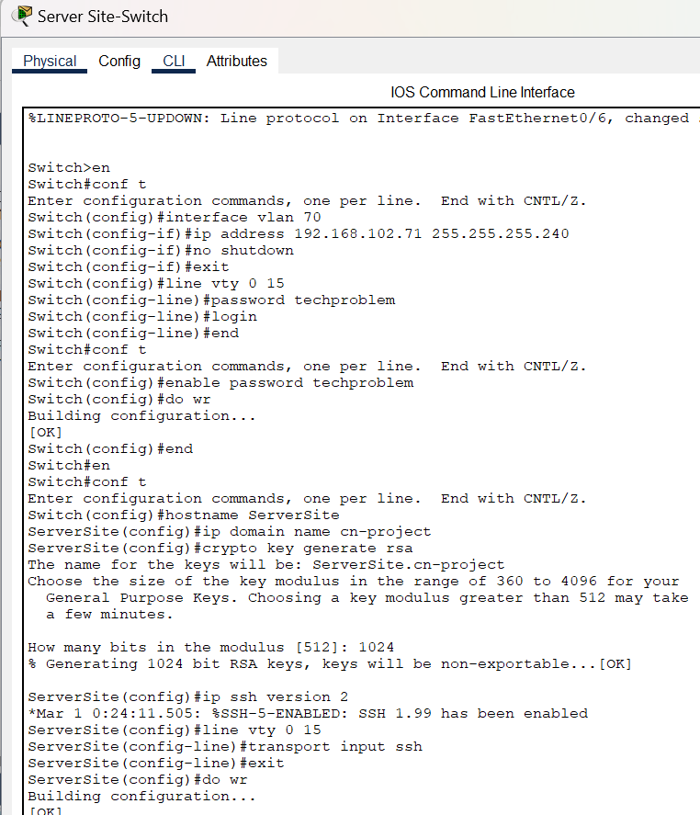

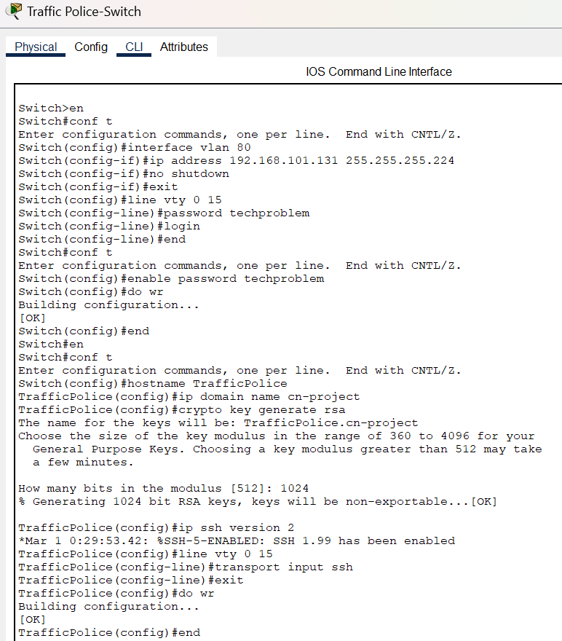

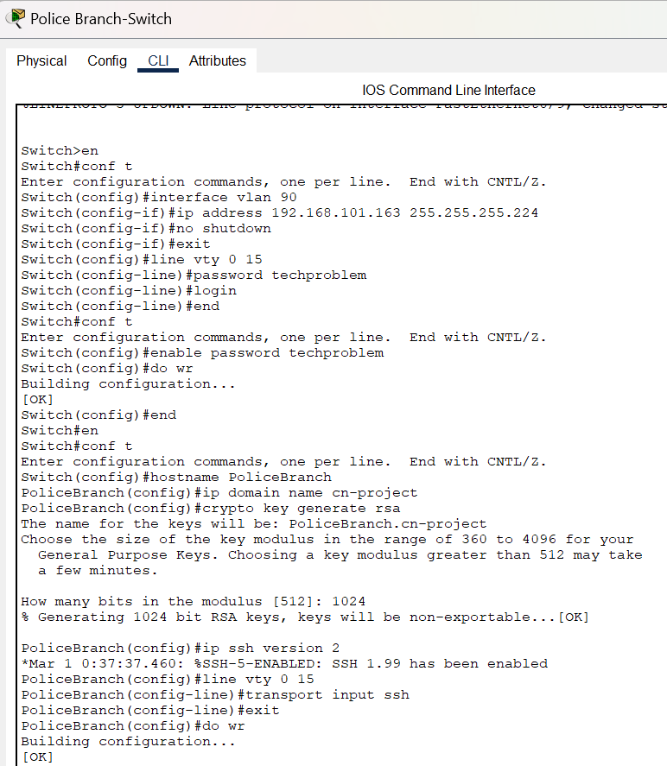

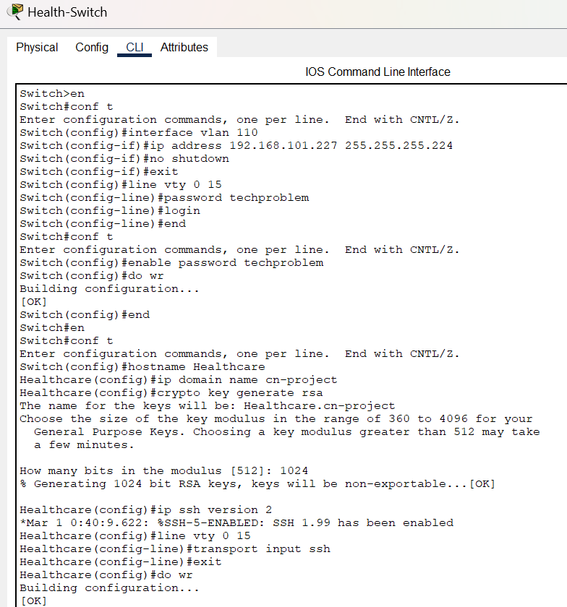

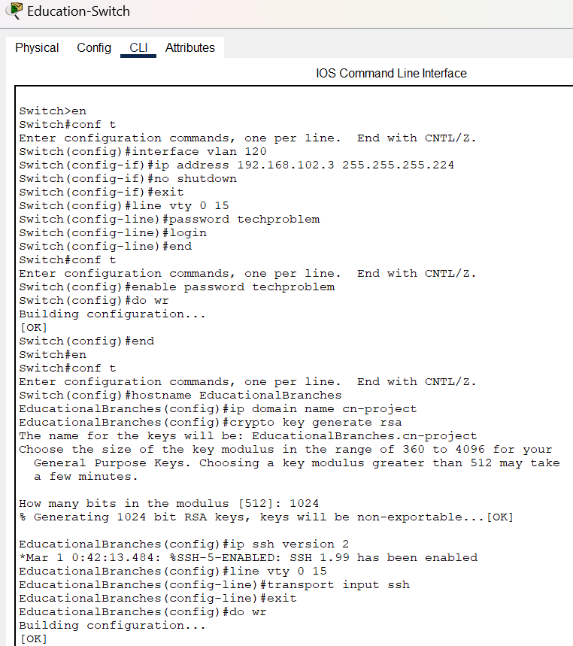

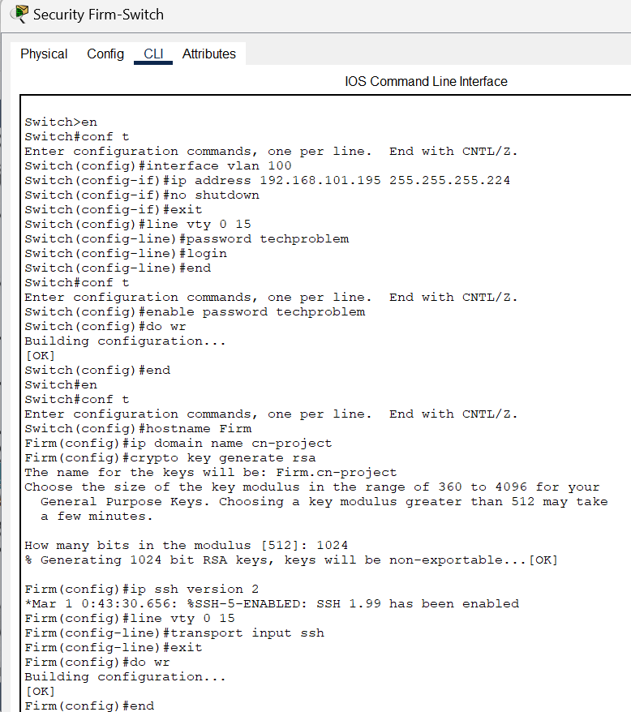

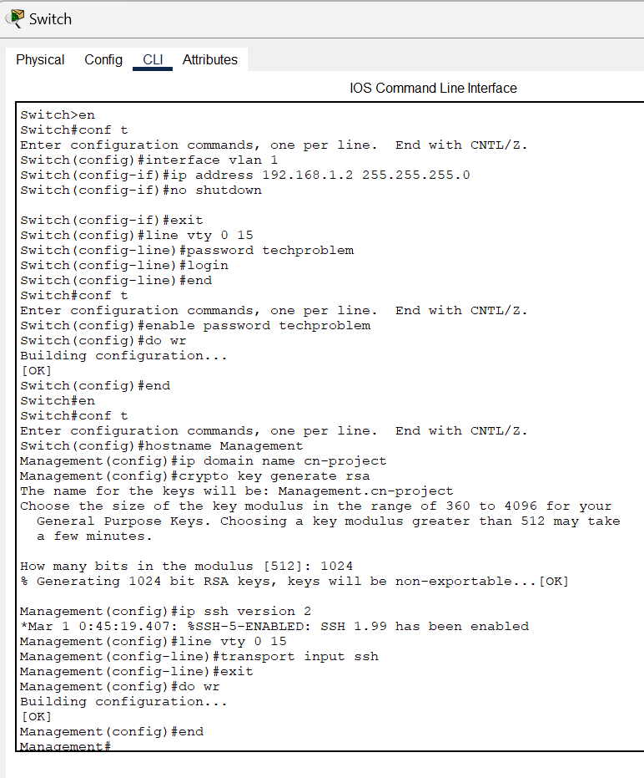

Subnetting/Assigning Ip Addresses:

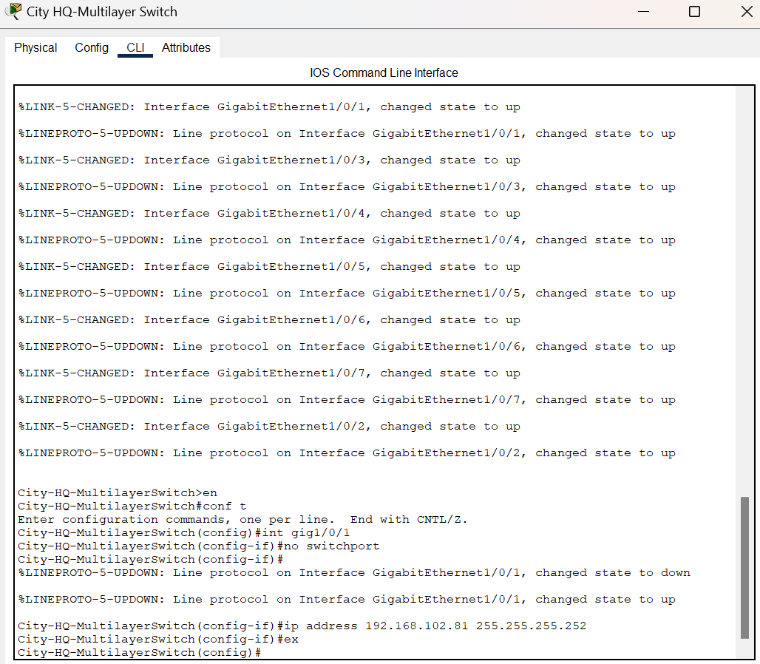

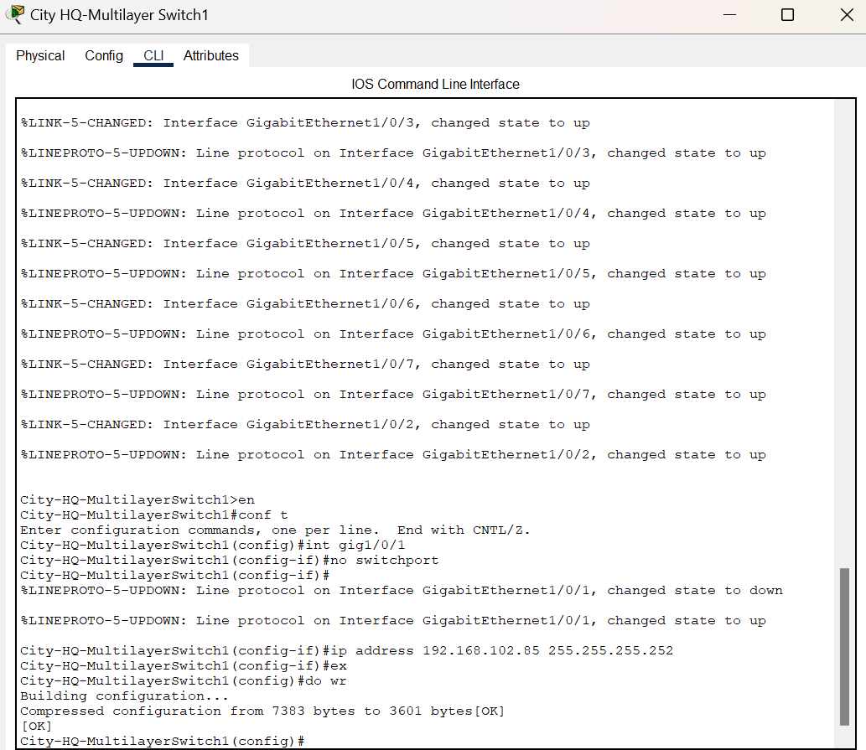

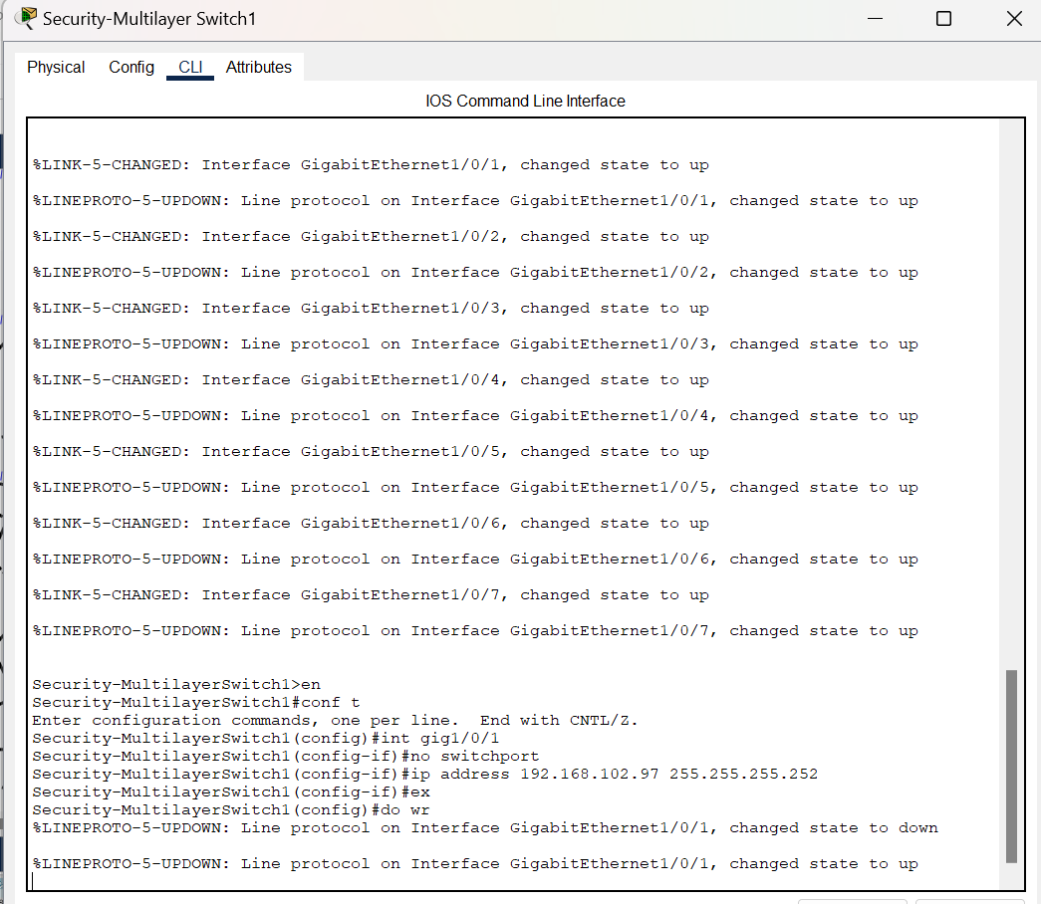

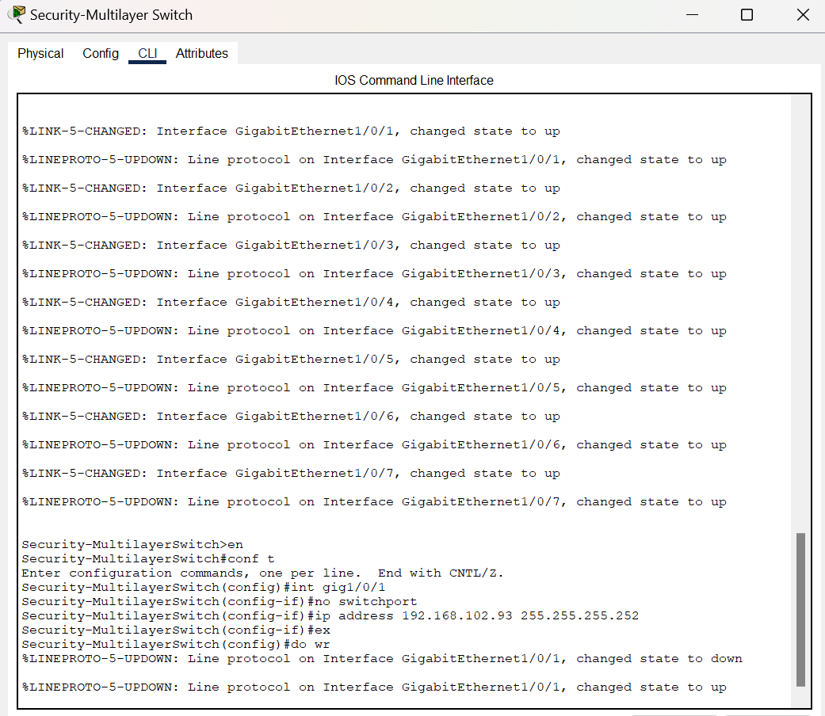

OSPF/Default route on Multilayer Switches:

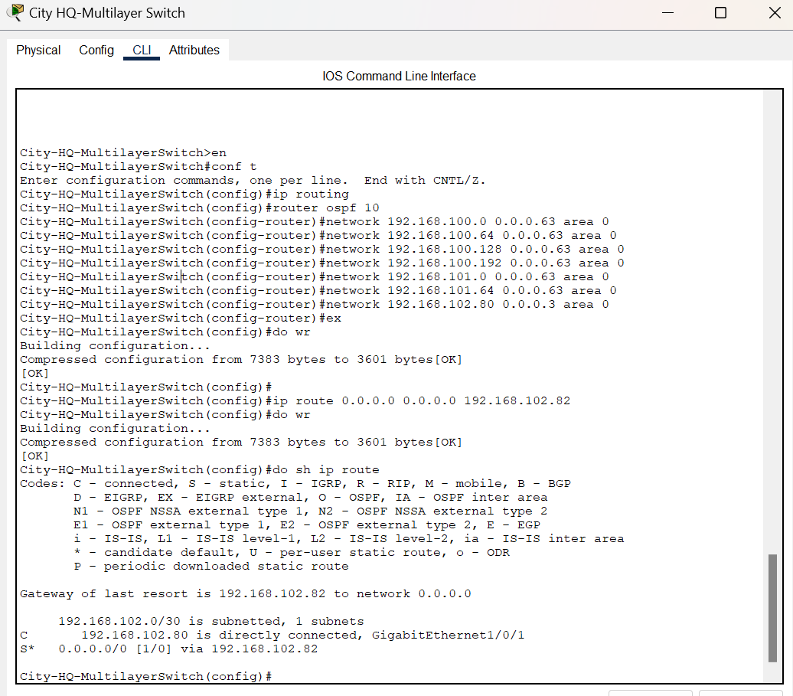

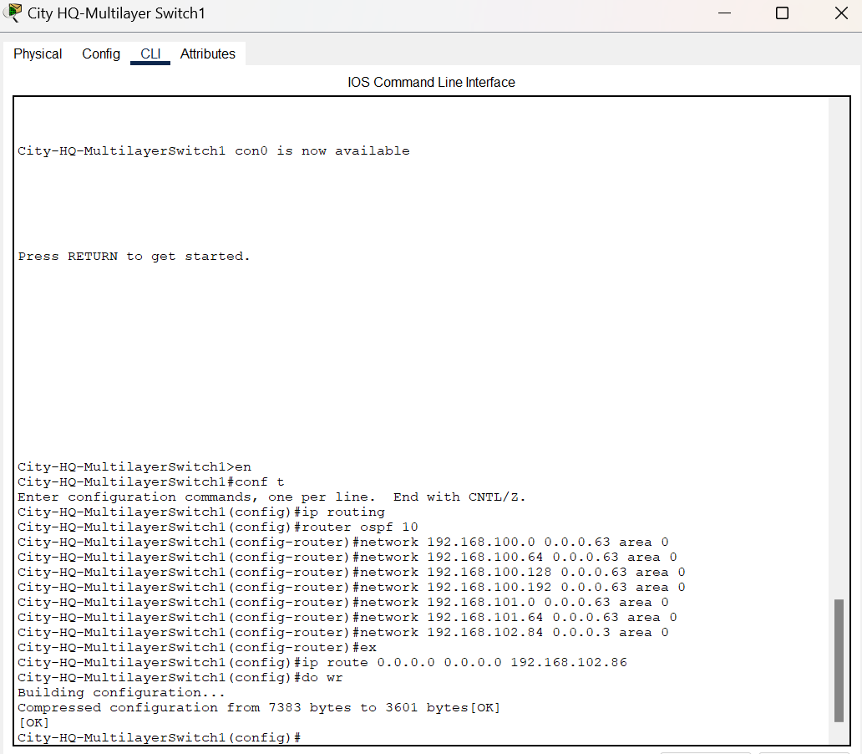

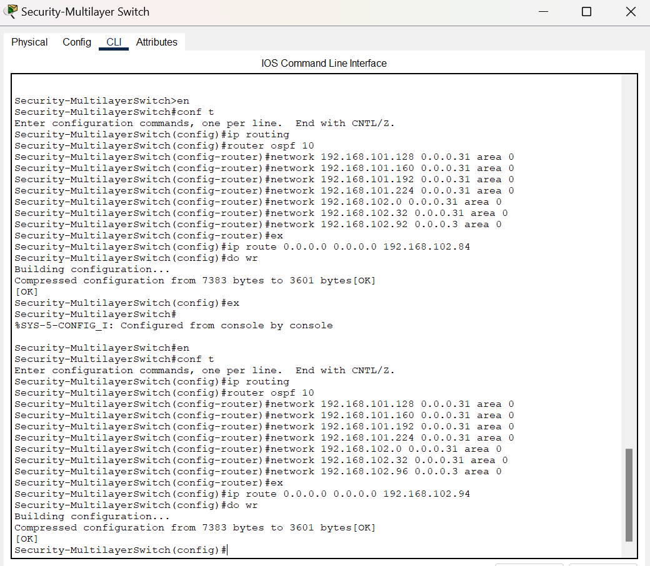



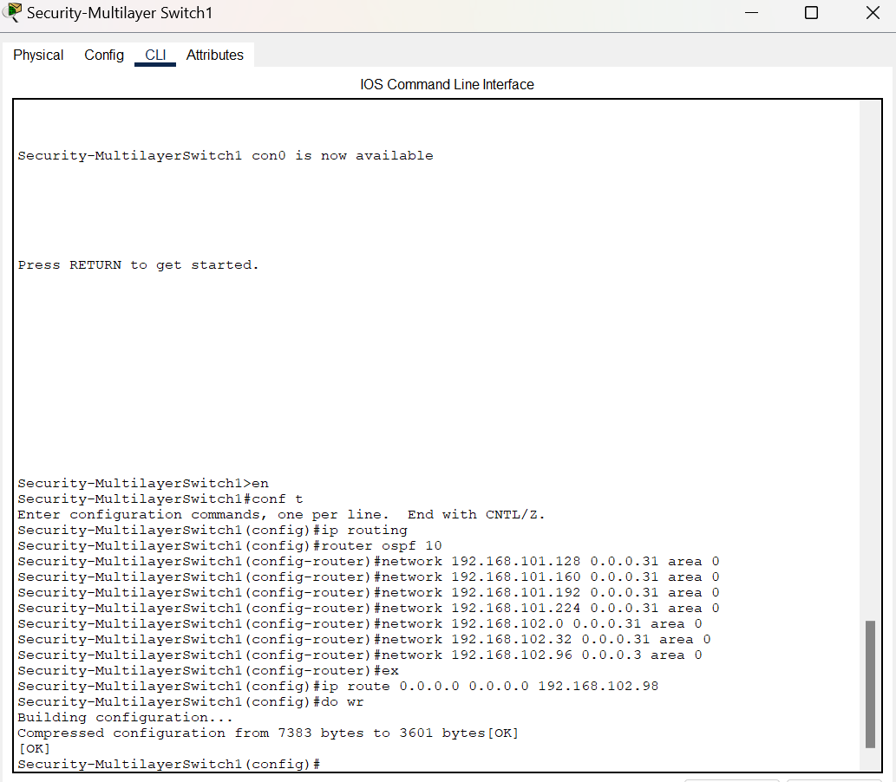

OSPF/Default route on Routers:

